Tanmay Fadnavis

SUID: 971141760

INTERNET Security

Lab - 2

# TASK 1: USING FIREWALL

Below are the screen shots for task1.

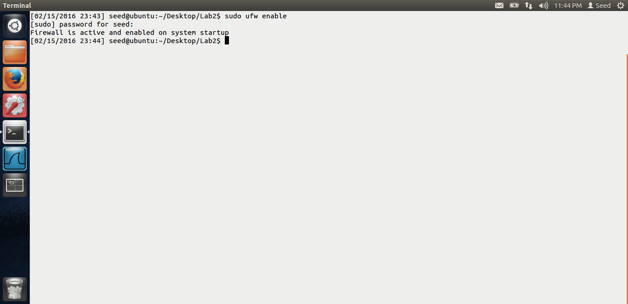

In the above screen shot, we can see that I have enabled ufw.

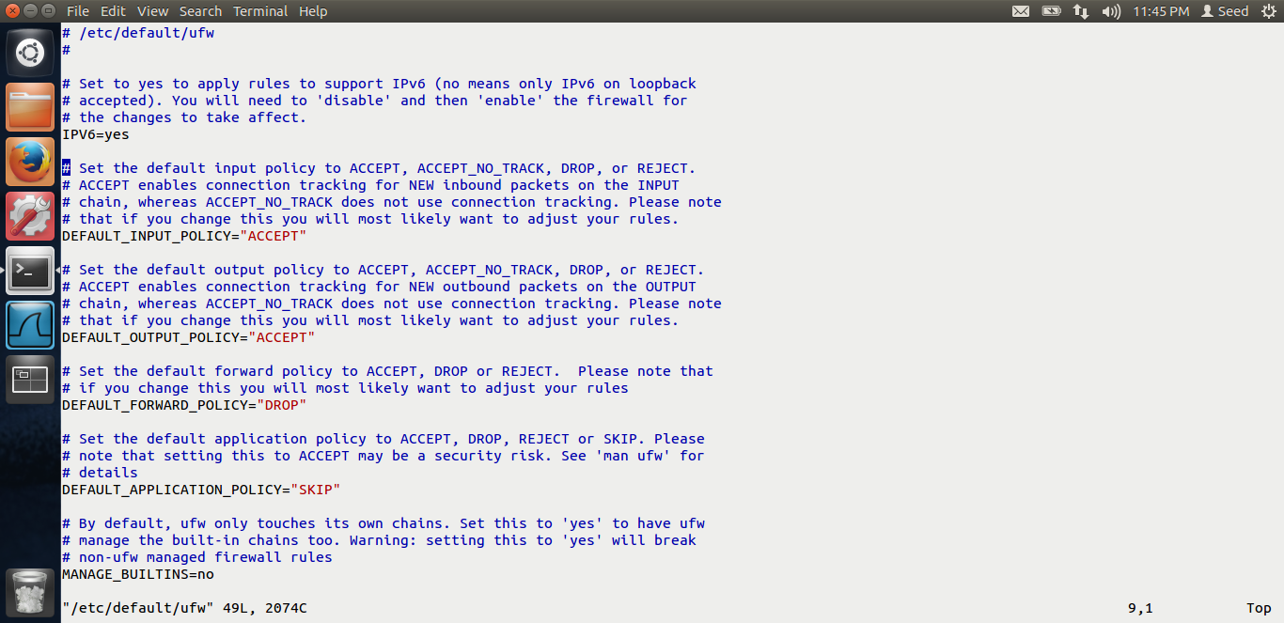

In the above screen shot, we can see that, I have done the default input policy to accept. Now let me write the rules.

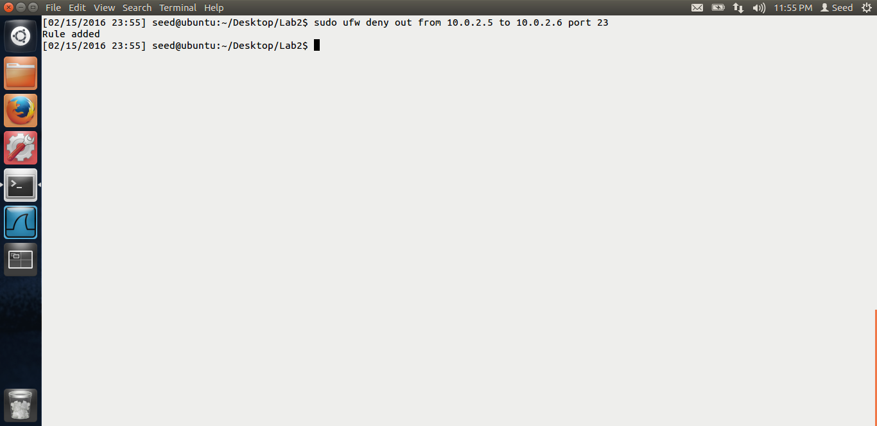

Above is the rule I am adding to avoid telnet from my original vm 10.0.2.5. to machine-B i.e. the clone VM whose ip is 10.0.2.6

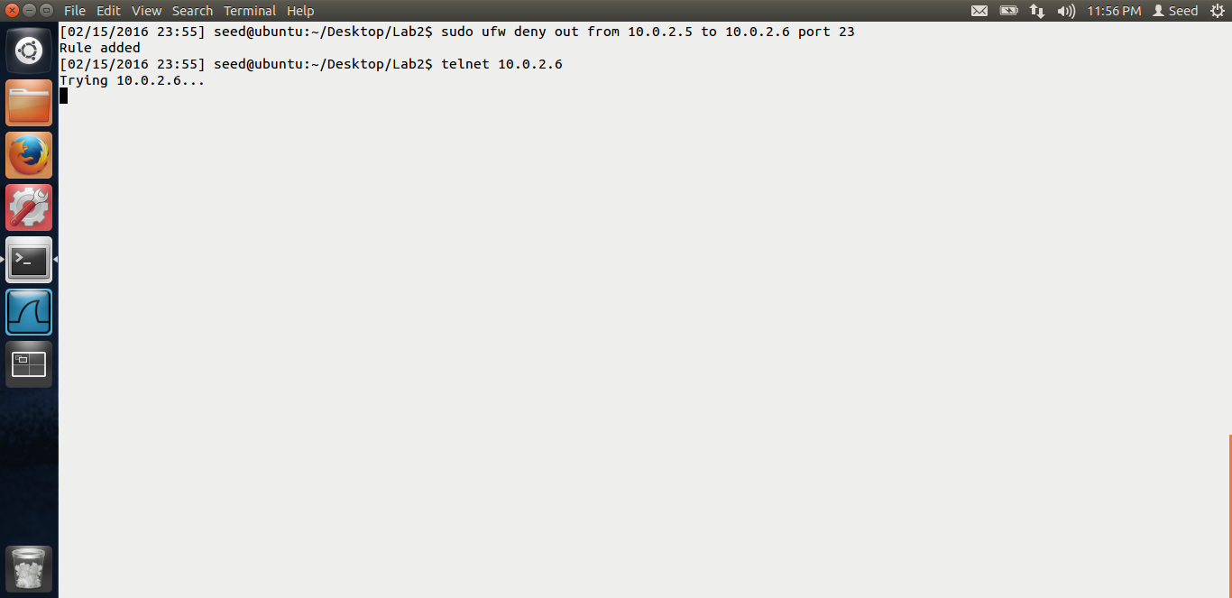

In the above screen shot, we can see that even though I am trying to telnet to my clone vm, i.e. machine B, I am not able to do the same. Thus, the rule was added successfully.

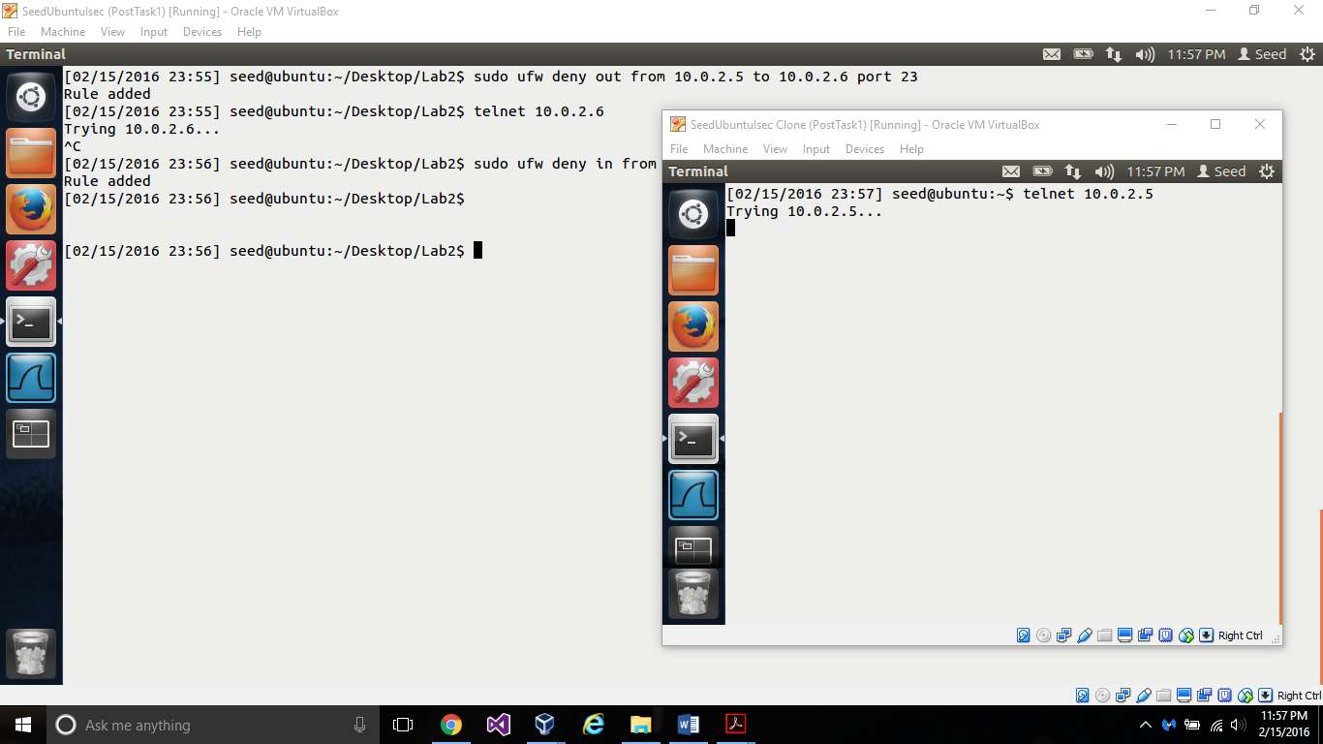

In the above screen shot, On the left side, you can see that, I have added the rule to prevent machine-B i.e. my clone to do telnet to my machine and on the right hand side, you can see that I am trying to telnet my original vm. We can see that, I am not able to do the telnet to my machine. Thus, the rule I have added successfully.

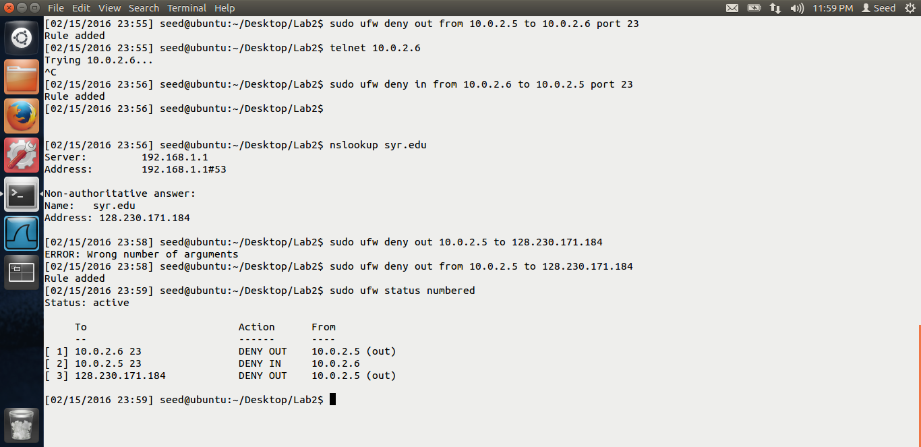

In the above screen shot, we can see that I have added the rule to prevent my vm to visit any external website. I have selected SU’s website. I looked up the ip address for SU using nslookup. After that I added the rule to block SU. Also, I have displayed all the 2 rules which I have added. You can see in the above screen shot.

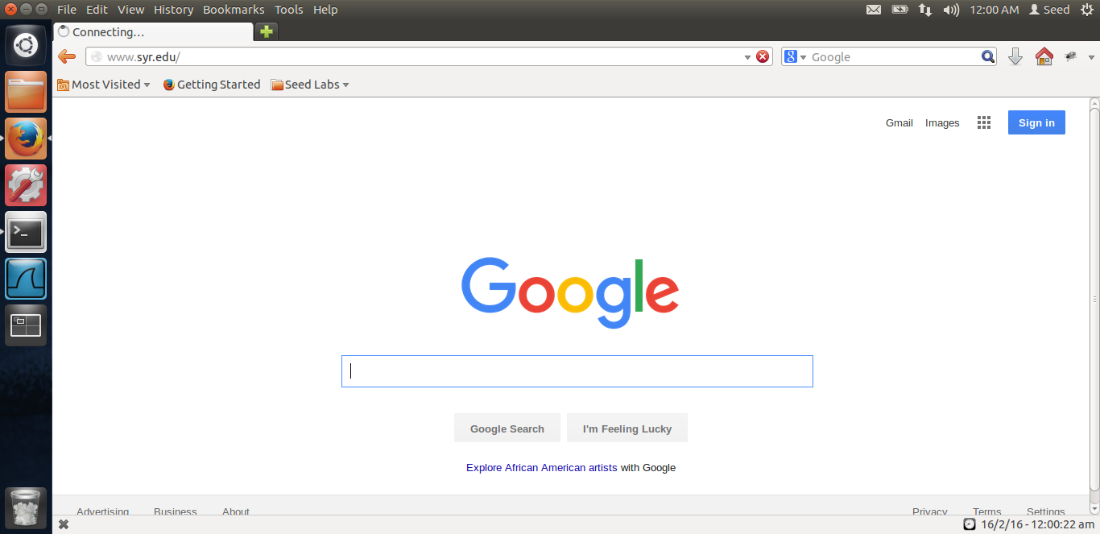

In the above screen shot, you can see that we can open google.com. But in the screen shot, in the task bar, you can see that I am trying to access [www.syr.eu](http://www.syr.eu), but I am not able to connect, as I have blocked Syracuse’s IP. Thus, the rule was added successfully. End of Task-1.

# TASK 2: HOW FIREWALL WORKS

The screen shots for task 2 are below. In this task, we have to write the LKM using netfilter.

I have done all the initial set-up. I will show the output first and then will explain the code.

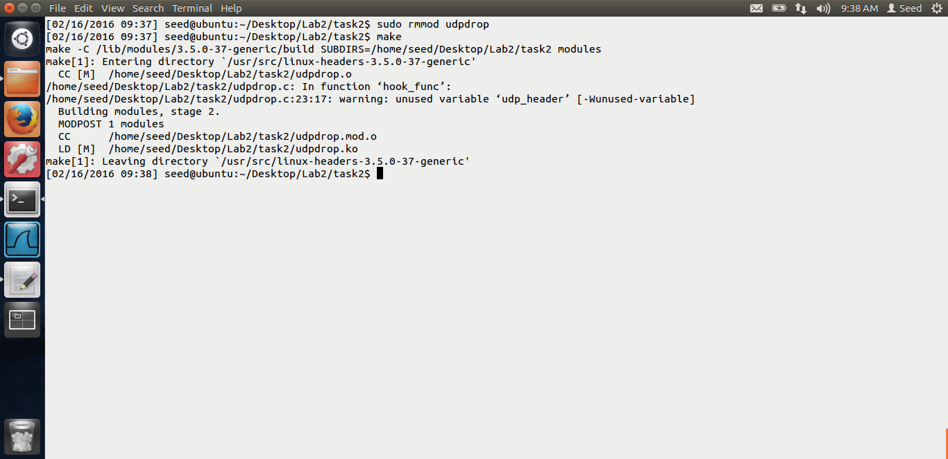

The name of my program is udpdrop. Here, I have used to udp dropping packets program and modified it to include more rules. In the above screen shot, I am doing the make command to make the LKM.

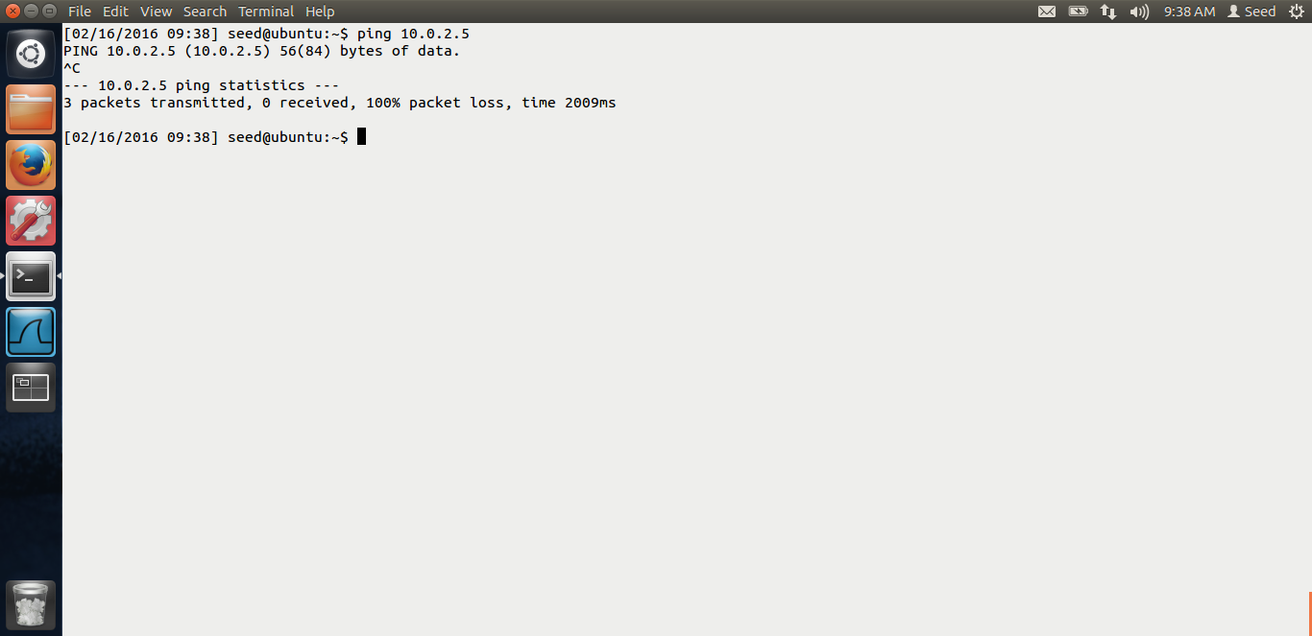

In my code, I have added the rule to avoid telnet from other machine. I.e. my original vm cannot be telneted from other virtual vm. In the screen shot, we can see that when I am doing telnet from my virtual vm to my original vm, there is a 100% packet loss.

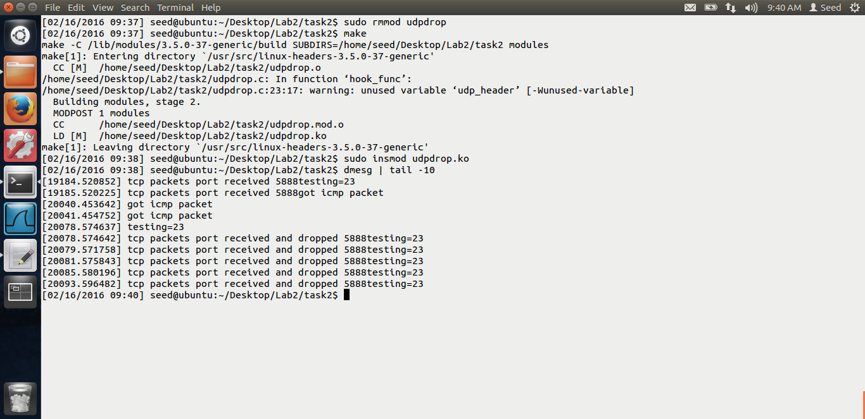

This is the log output. In the output, you can see that icmp packets have been received. “got icmp packet” and the packets have been dropped. Thus, this rule is successful. I will show the code In the end.

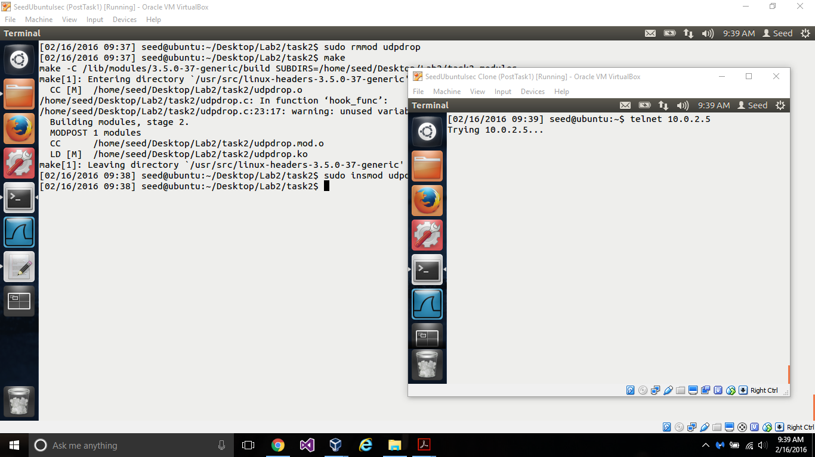

Above is the screen shot showing the same.

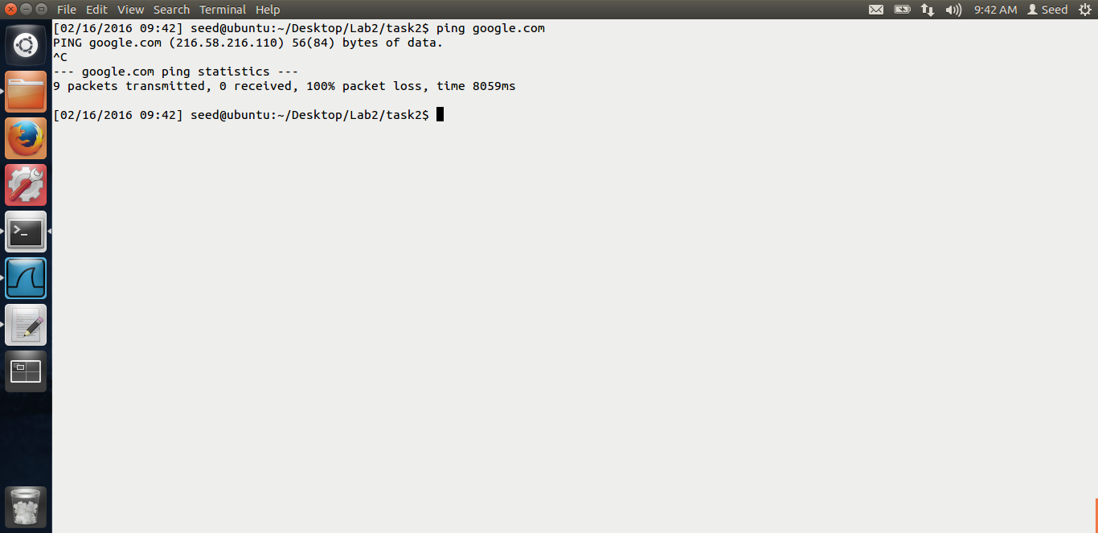

Here, I am pinging google.com from my original vm. But even then its showing packet loss. Reason is, all the incoming packets I have blocked , incoming ICMP packets. Hence there is data loss.

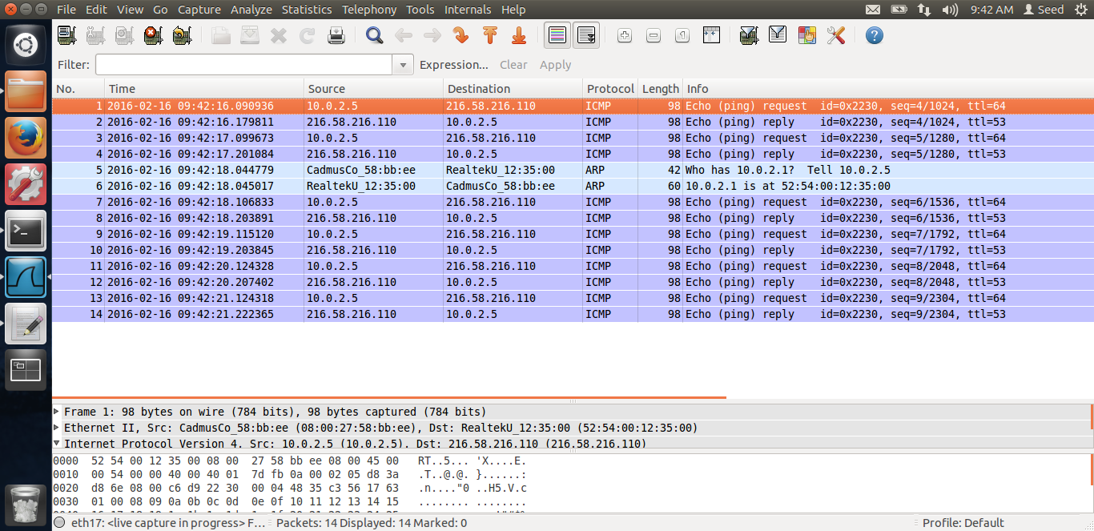

In the wireshark, we can see that google is replying, but even then there is a packet loss. Reason is, I am using the NF_INET_PRE_ROUTING hook. Hence as soon as the packet is captured, they are dropped.

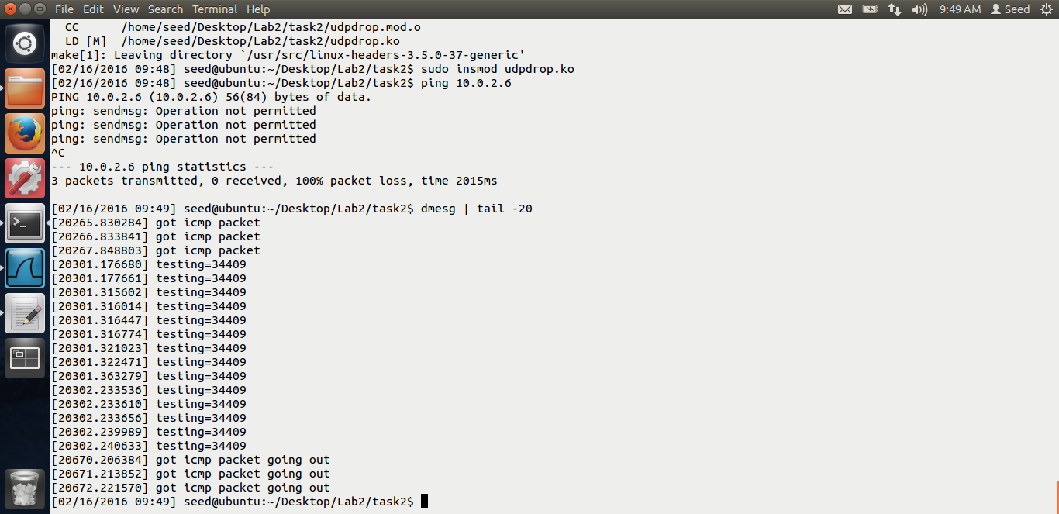

Above is the screen shot, where I have set the same rule on the outgoing packets. Thus, we can see that sendmsg operation is permitted. In the logs, the output says “got icmp packet going out”. Thus, this time I have used the filter NF_INET_LOCAL_OUT. I am blocking outgoing packets from my local machine.

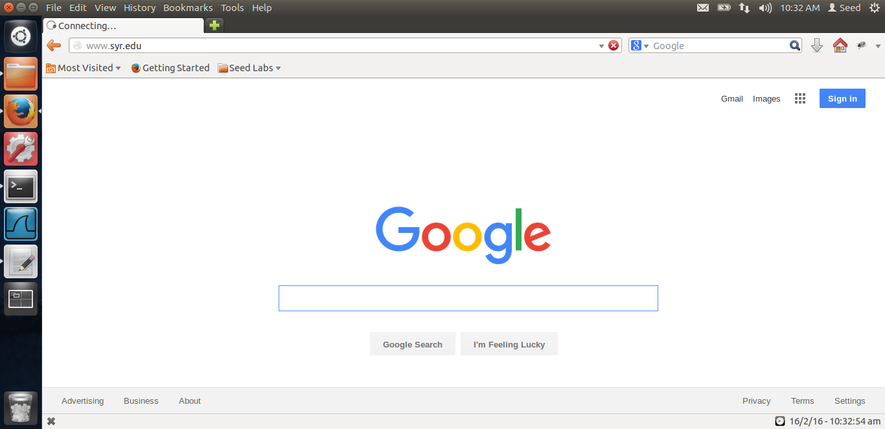

Above is the screen shot, where I have blocked [www.syr.edu](http://www.syr.edu). Here I am using the incoming filter, you can see in the screen shot, in the address bar that the site is [www.syr.edu](http://www.syr.edu), but I am not able to connect. But I have opened google.com. Thus the rule works for blocking [www.syr.edu](http://www.syr.edu) as well.

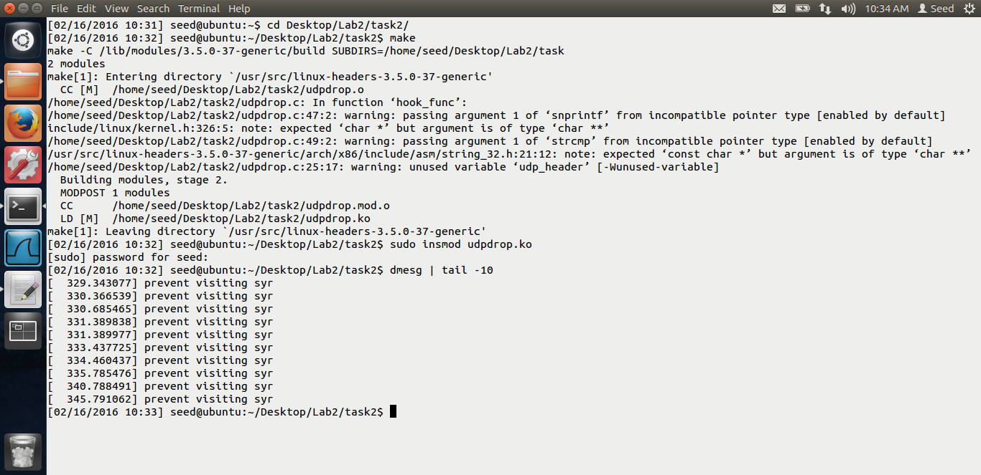

In the above screen shot, we can see the message, prevent visiting syr. Thus, from the logs it is verified that [www.syr.edu](http://www.syr.edu) has been blocked. Now let us look at the code.

To conclude, the following rules I have added.

On the incoming packets, i.e. NF_INET_PRE_ROUTING.

1. Block telnet from machine-b to my machine, local machine.
2. Block icmp packets from other machines to my machine.
3. Block [www.syr.edu](http://www.syr.edu)

On NF_INET_LOCAL_OUT – I have blocked the icmp packets from my local machine to go out.

Below are the screen shots for code.

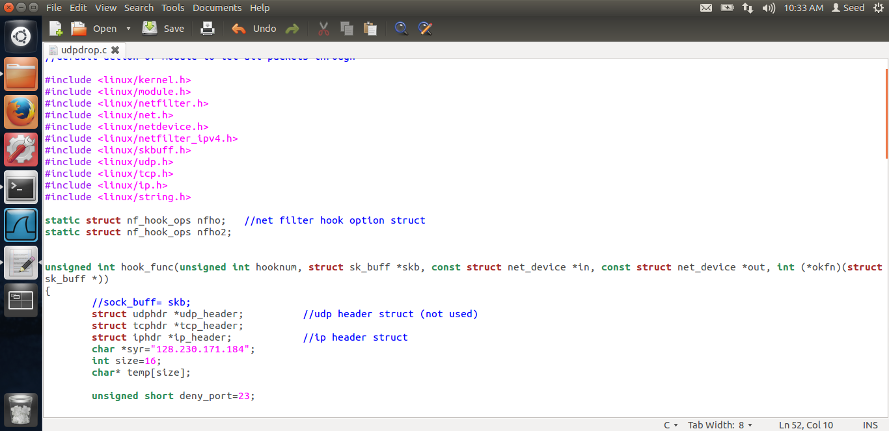

In the above screen shot, we can see I have made 2 hooks of struct nf_hook_ops, one for the incoming hook and one for the outgoing hook. I am using the iphdr, tchdr data structues. Also, I have hard coded syracuse’s ip to block it and I have hardcoded the port,23 to block telnet.

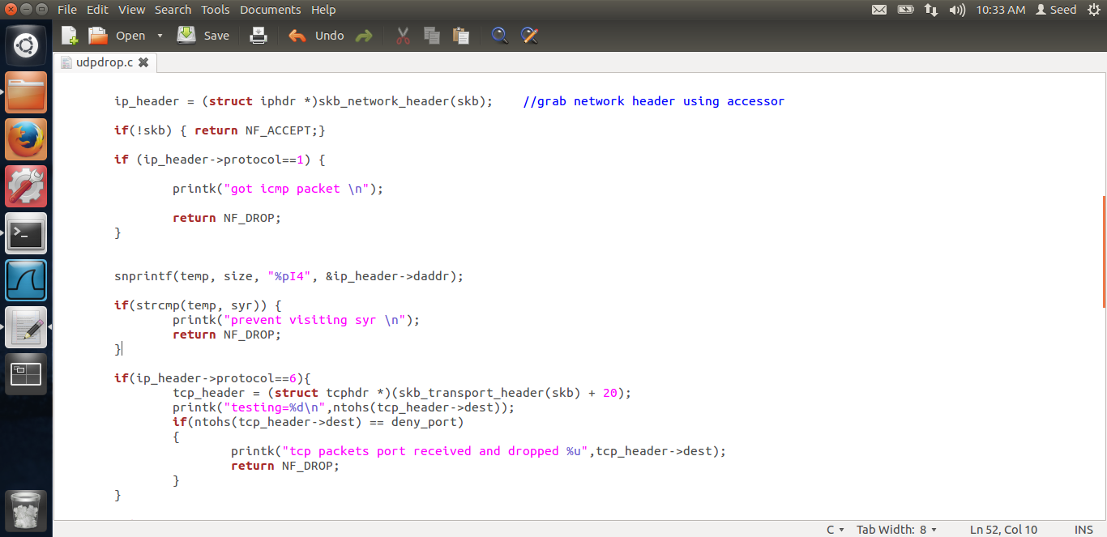

Here, I am first type casting the packet into the ip header.

Fir the icmp rule, I am checking if the incoming packet has protocol number 1, i.e ICMP. If it is, I am dropping it. Then for the second rule, to block the telnet ports. I have type casting it to the tcphrd format. But notice that while typecasting, I am adding plus 20 to it. The reason is, tcphrd is also type casted from the start of the iphdr hence it was giving me issues initially and I was not able to capture the port number. After I added 20 to it, I was able to capture the port. After capturing I am converting it from network to host order. After that is done, I am comparing and checking whether it is 23. If it is means someone is doing telnet to my machine. Hence I am dropping those packets.

For the syr.edu rule, I am first storing the ip destination address into the string. After that I am doing the string compare with the hard coded syr,ip. If they are same, then I am blocking the ip, i.e. dropping all the packets. Thus I have implemented the rules for the incoming packets.

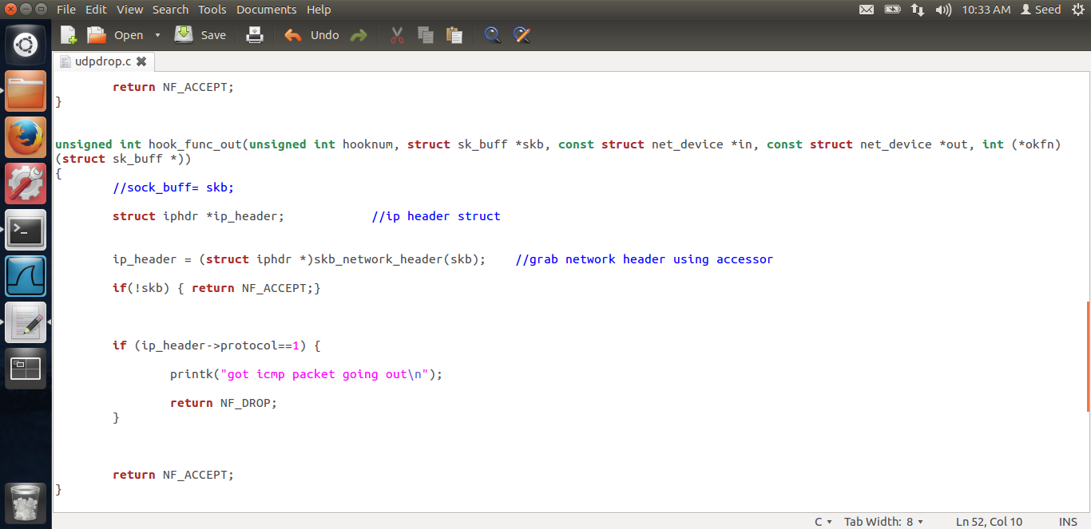

In the above screen shot, I have added another function for the out going port. It’s a simple function which checks the ip protocol and if its an icmp request, I am dropping the packets.

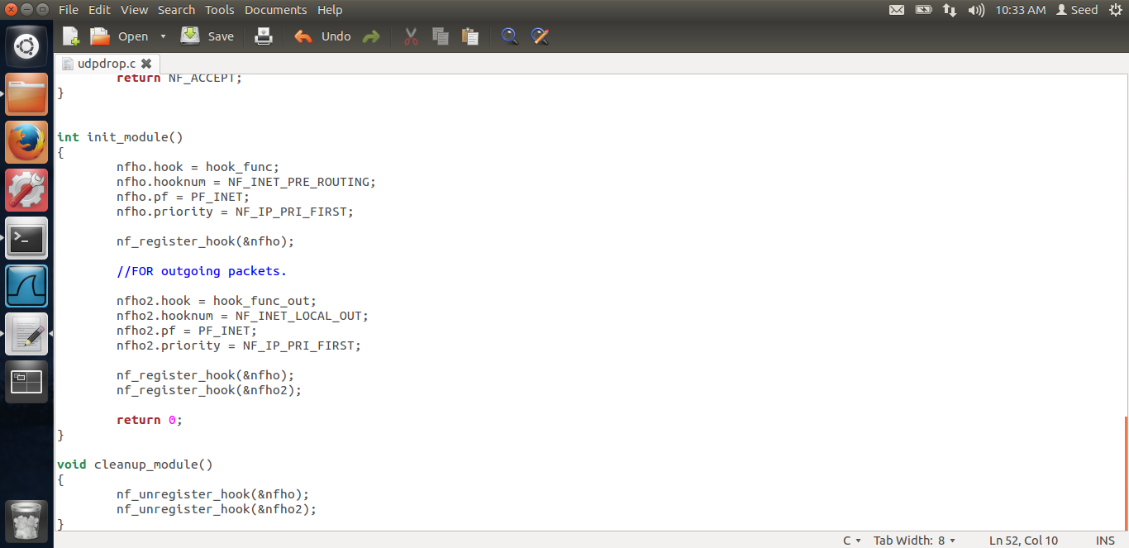

In the init module, I am just registering those 2 hooks, For the first hook, the hook is NF_INET_PRE_ROUTING and the second hook is NF_INET_LOCAL_OUT. Then in the cleanup module I have unregistering those hooks. Thus Above is the code for LKM using NET FILTER.

Question 1:



Above is the diagram given by the TA.

NF_INET_PRE_ROUTING is where the packets come in. The packets have just been received.

NF_INET_LOCAL_IN is called before being passed to the process.

NF_INET_IP_FORWARD is it the packet is destined to pass to another interface.

NF_INET_POST_ROUTING is the final netfilter hook before the packet is put on wire.

NF_INET_LOCAL_OUT is the hook for the packets being produced on the local machine.

Question 2:

For egress filtering, hook should be placed on 4 and 5, NF_INET_POST_ROUTING AND NF_INET_LOCAL_OUT. For ingress filtering, hook should be placed on 1, NF_INET_PRE_ROUTING.

Question 3:

Yes, we can modify packets using netfilter. Once we receive the packets, we can extract all the information from ip header, to tcp header, to data. Change the data, modify the packets before sending and then send the modified packet.

End of task 2.

# TASK 3: EVADING EGRESS FILTERING

The screen shots for task-3 are below.

I am setting up my firewall on my original VM. I am using 2 VMs in this task, original and 1 clone.

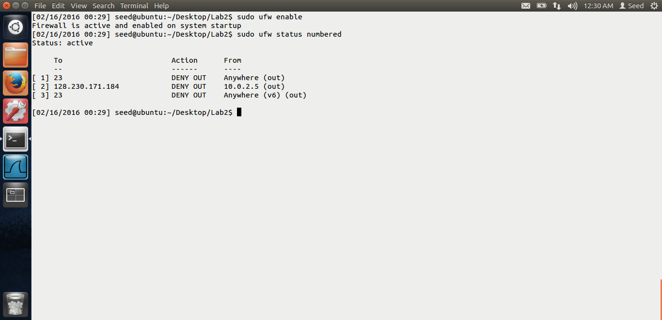

In the above screen shot, you can see that I have set-up the rules as mentioned in the lab, i.e. block the telnet and block syr.edu I have setup the rules using ufw.

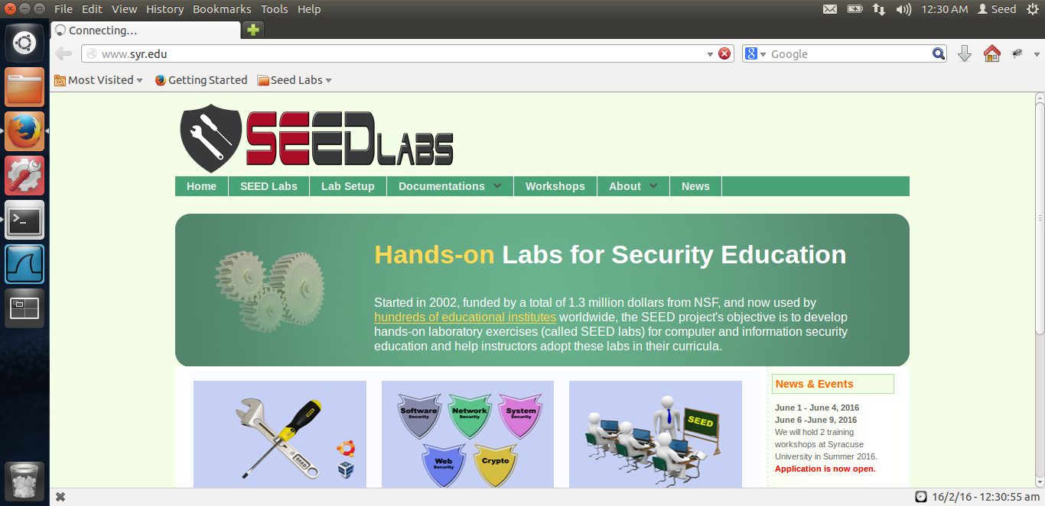

In the above screen shot, you can see in the address bar, I am trying to access the [www.syr.edu](http://www.syr.edu), But I am unable to access it because of the rules.

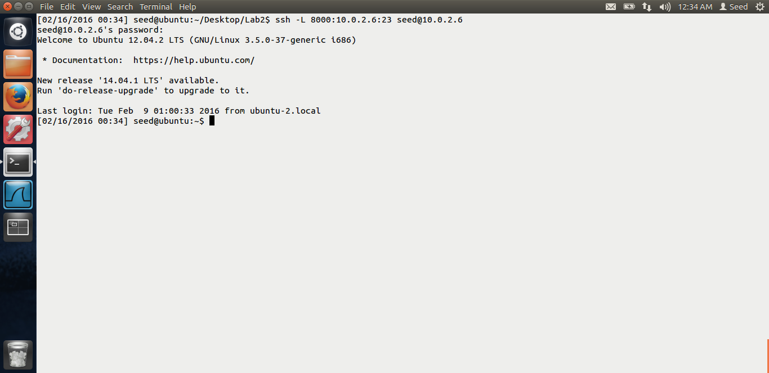

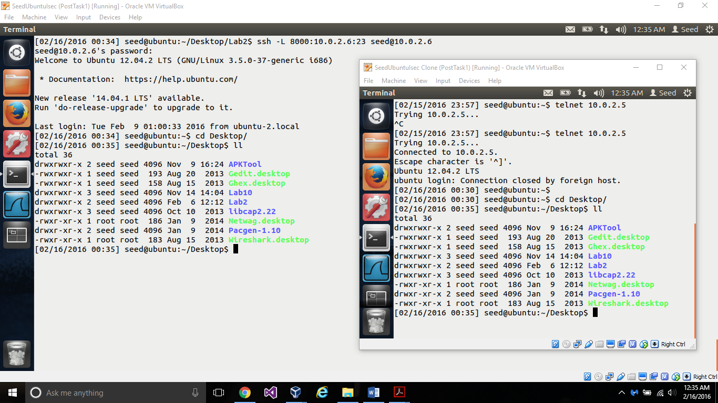

In the above screen shots, you can see that I have setup the ssh tunnel using the command given in the lab description. Thus, here, left side is my original vm, where I have blocked telnet. But my creating SSH Tunnel, I SSH on my port 8000, to my clone vm, i.e. 10.0.2.6, using clone vm only i.e. [seed@10.0.2.6](mailto:seed@10.0.2.6), Thus, after the tunnel is set-up when I go to desktop, we can see that I have successfully telnet to clone vm, both the desktops are the same. Thus the SSH tunnel is successful.

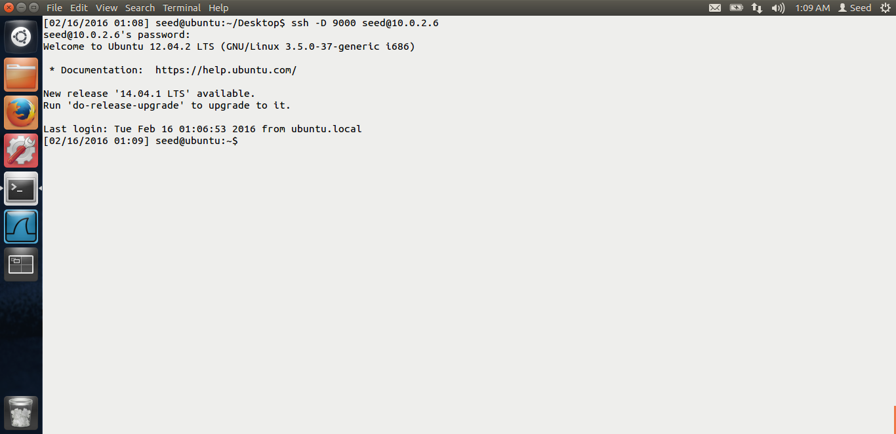

Connecting to syr.edu using SSH tunnel. Here in the above screen shot, we can see that, I have done the SSH tunnel and using dynamic port forwarding, we set-up the tunnel.

Also, we need to change the settings in firefox.

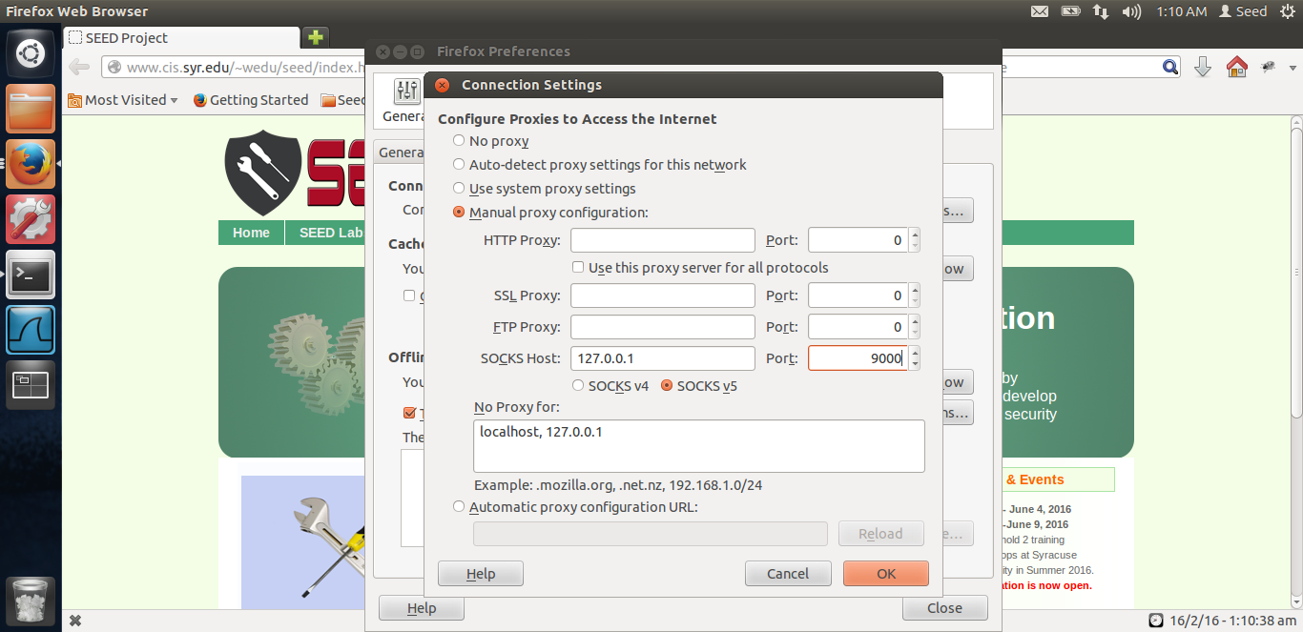

In the above screen shot, we can see that, I have changed the proxy to SOCKS host, and I am using the localhost and port 9000, because the tunnel is using port 9000.

Now the set-up is done.

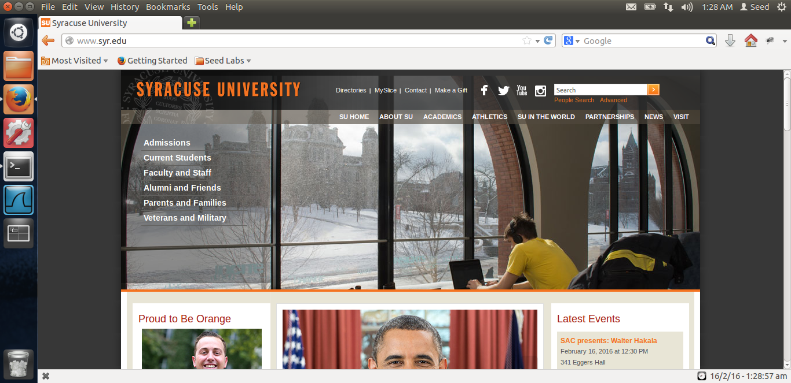

When I visit [www.syr.edu](http://www.syr.edu), even though the site is blocked, I am able to access it, Thus, I have bypassed the firewall and I am accessing syr.edu using the SSH tunnel.

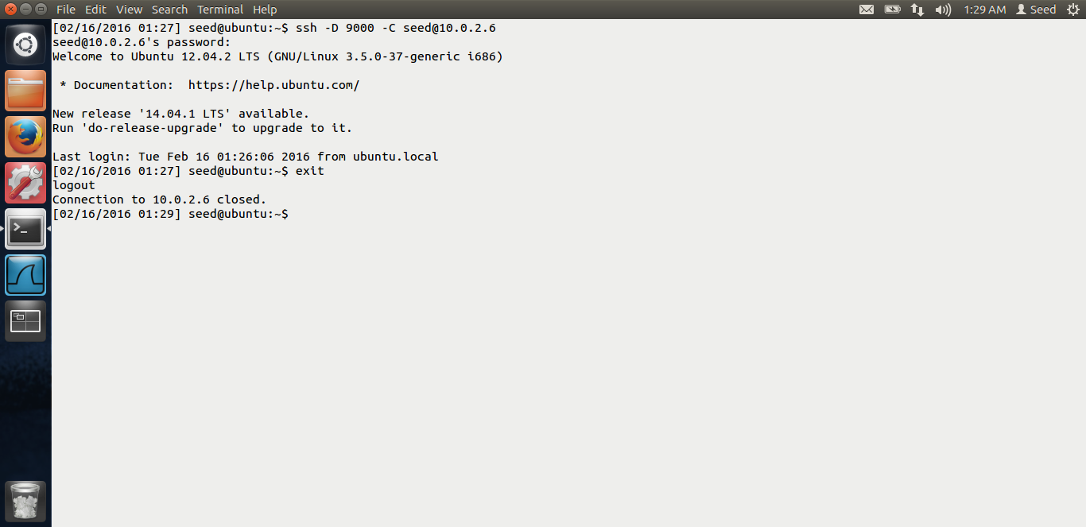

In the above screen shot, I am breaking the SSH tunnel.

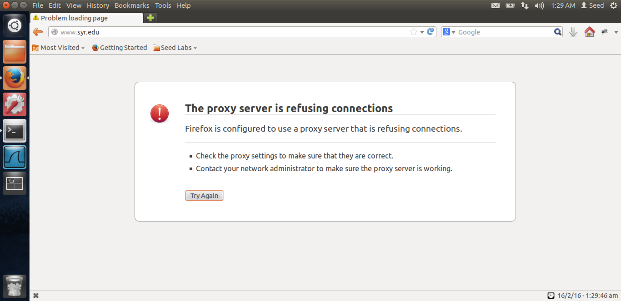

Thus, once the tunnel is broken, I am not able to access syr.edu because of the firewall.

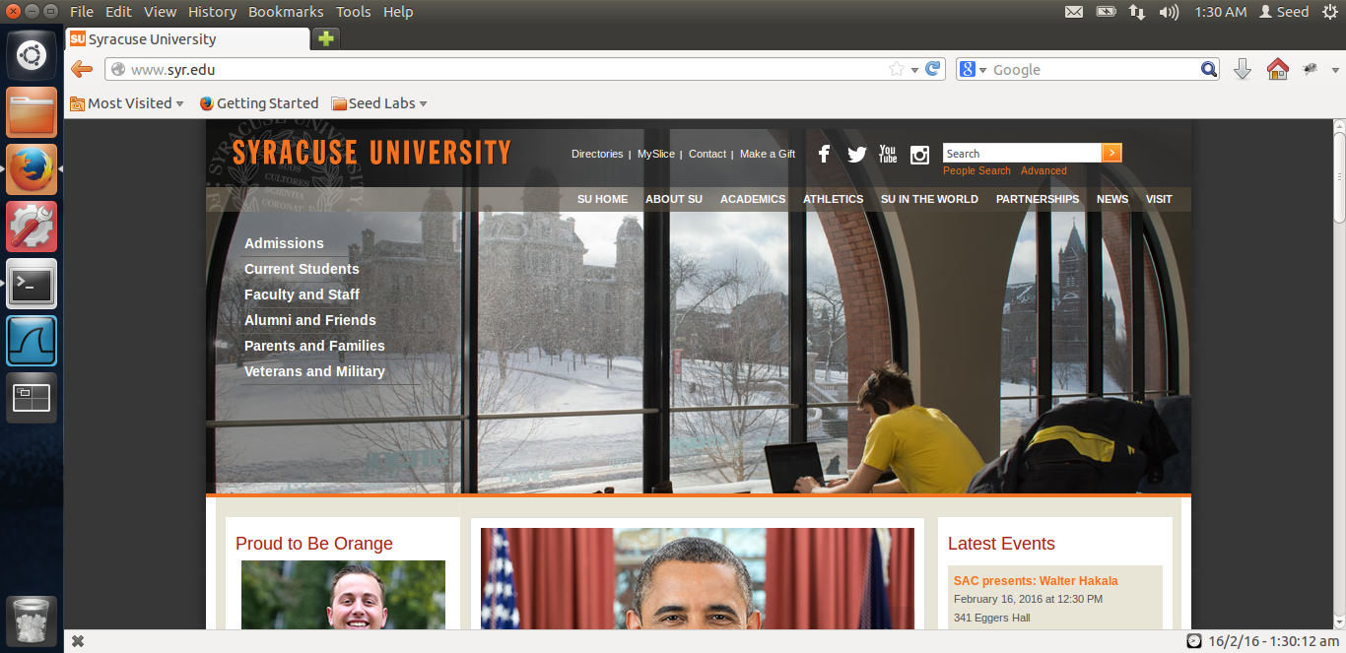

If I re-establish the tunnel, I can access syr.edu

Reason is, I am doing SSH to my clone VM. My clone VM can access syr.edu, thus using dynamic port forwarding, I send the request to my clonevm. My clone vm makes the request to syr.edu, Once it gets the packets/response, it sends it back. Also, as our firefox is listening on port 9000, it gets the reply and displays it. Thus task-3 is successful.

**QUESTION 4:**

If ufw blocks port 22, port for SSH, we cannot set the SSH tunnel. Screen shots are below.

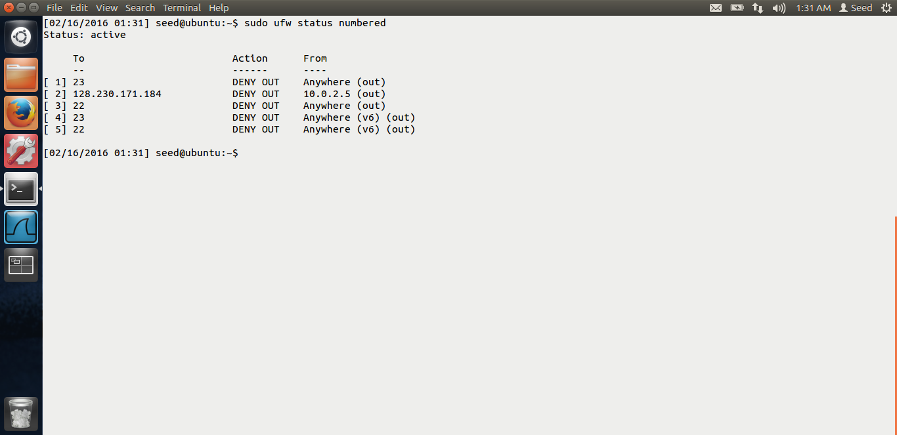

In the above screen shot, we can see that I have added the rule to block port 22.

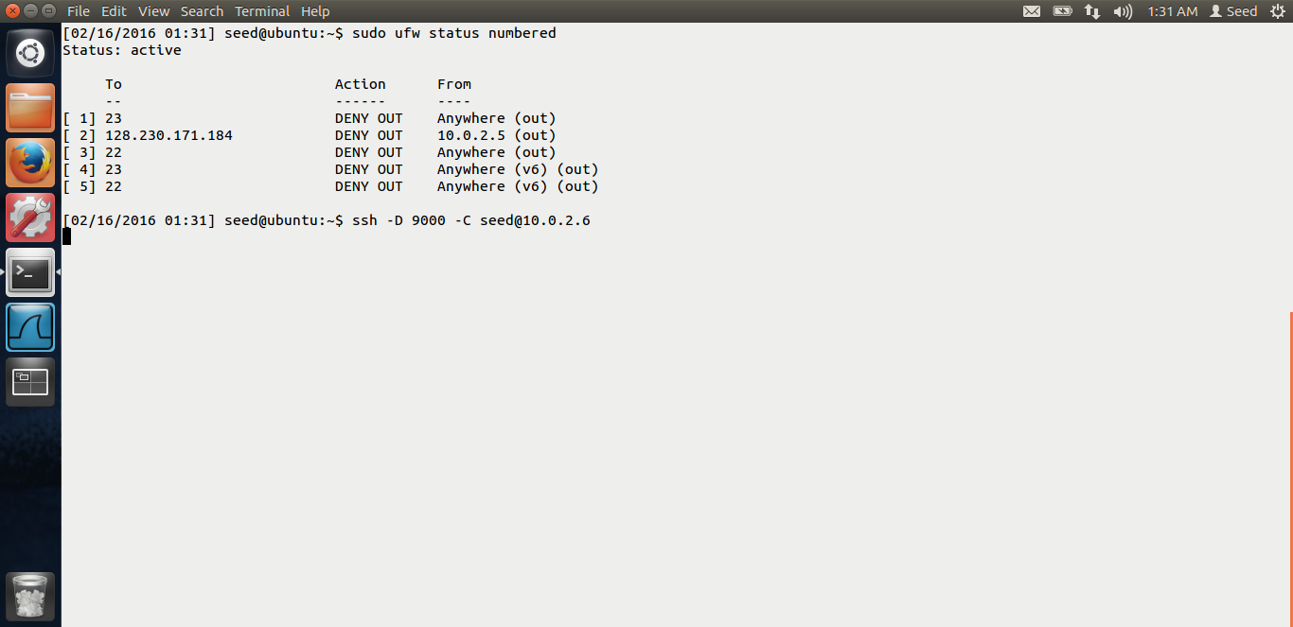

In the above screen shot, even though I am trying to create an SSH tunnel, because of the firewall, I am unable to create the SSH tunnel and our attack fails. End of Task-3.

# TASK 4: WEB PROXY (APPLICATION FIREWALL)

In this task, I am using my original VM as machine-A and the web proxy I am setting it on my clone VM, using it as Machine-B.

Below are the screen shots for task-4.

I am configuring squid in my clone VM and trying sites from my original VM.

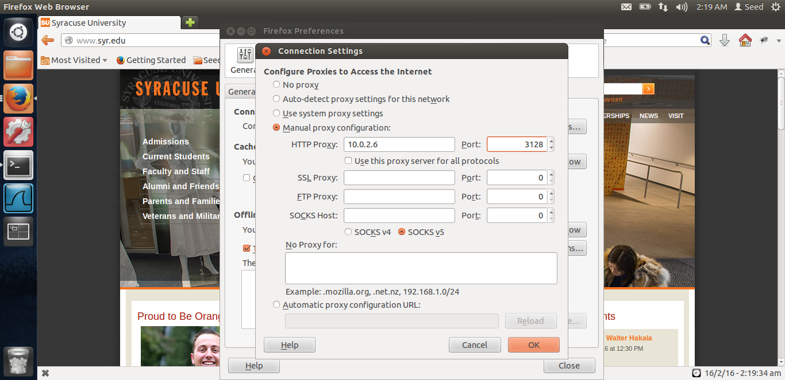

In the above screen shot, you can see I am configuring my proxy for my clone, i.e. squid web proxy.

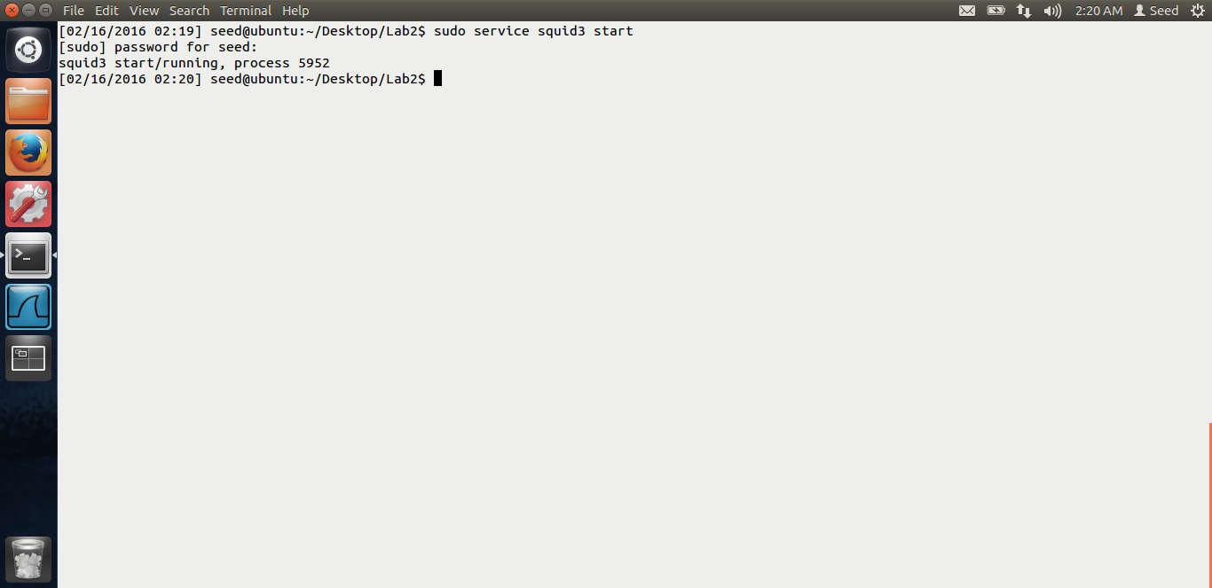

I am starting squid on my clone machine.

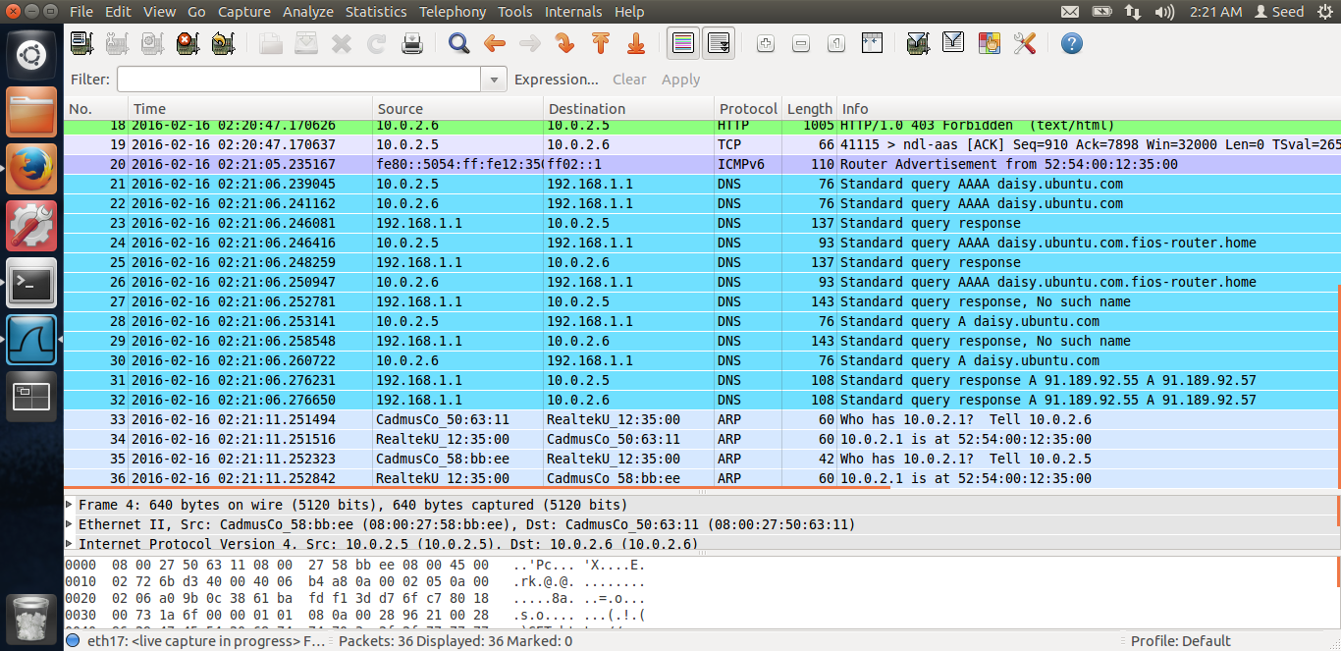

This is the wireshark traffic when I visit any site.

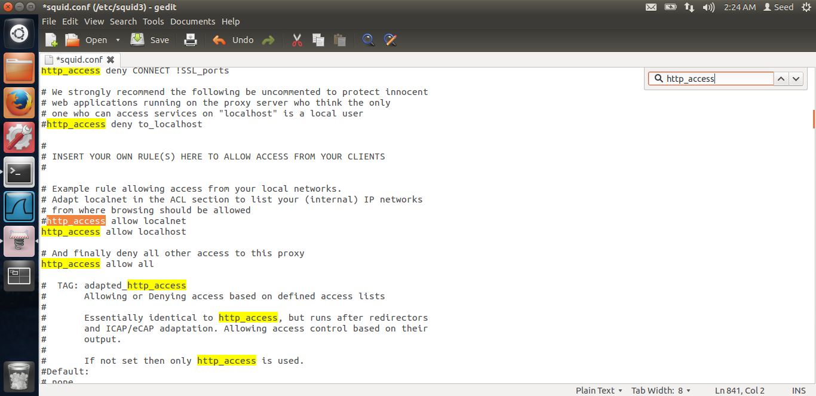

Above is the screen shot for the squid config file. Here, to allow all the sites, if I do http_access allow all, I will be able to visit all the sites.

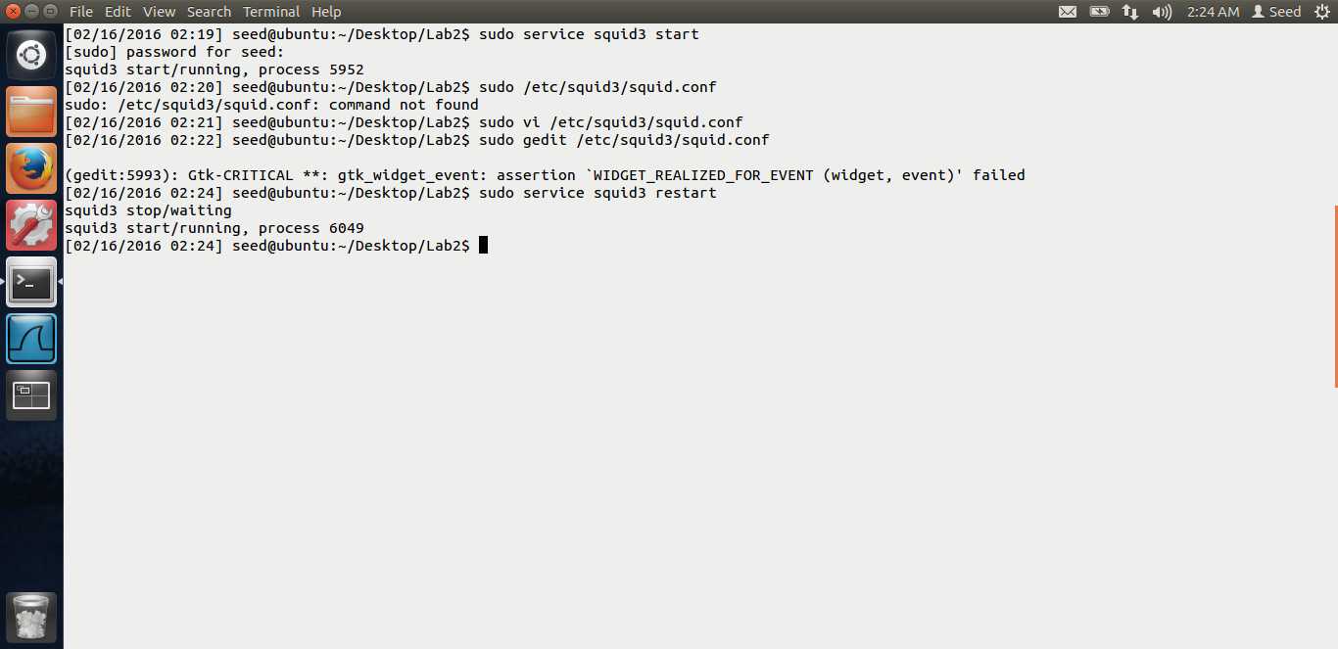

I restart the squid server.

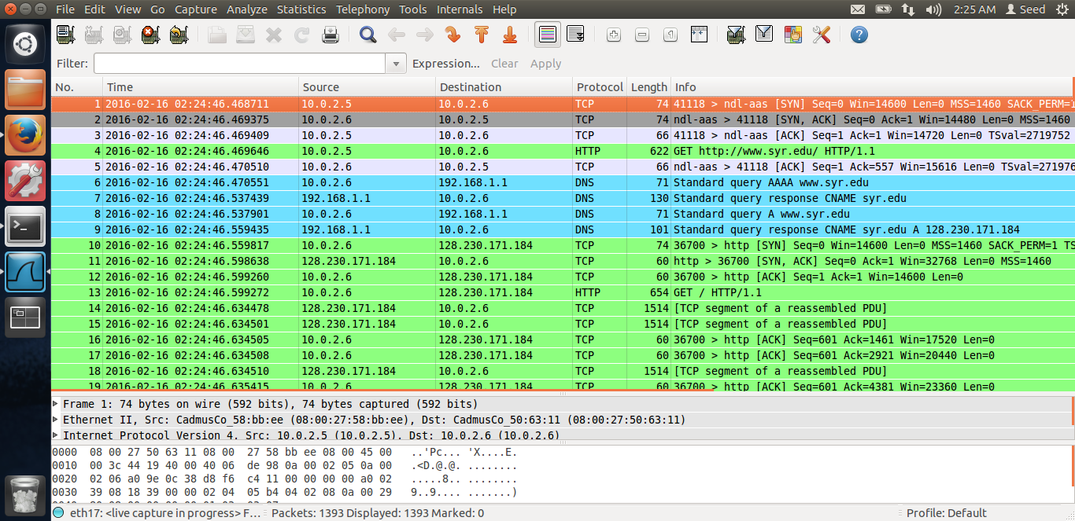

In the above wireshark screen shot, we can see that if I visit for e.g. [www.syr.edu](http://www.syr.edu), I am getting the response. Thus, all the sites are allowed.

Now, let us allow only google.com

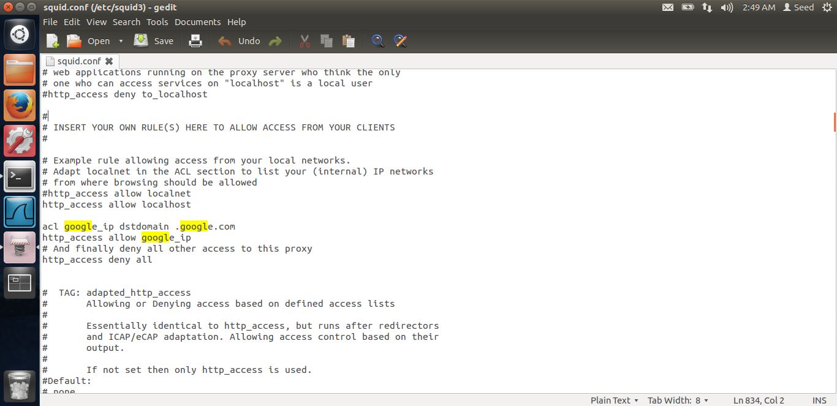

In the above screen shot, we can see that I am allowing google.com, i.e. my original vm can access google.com but I am denying all others.

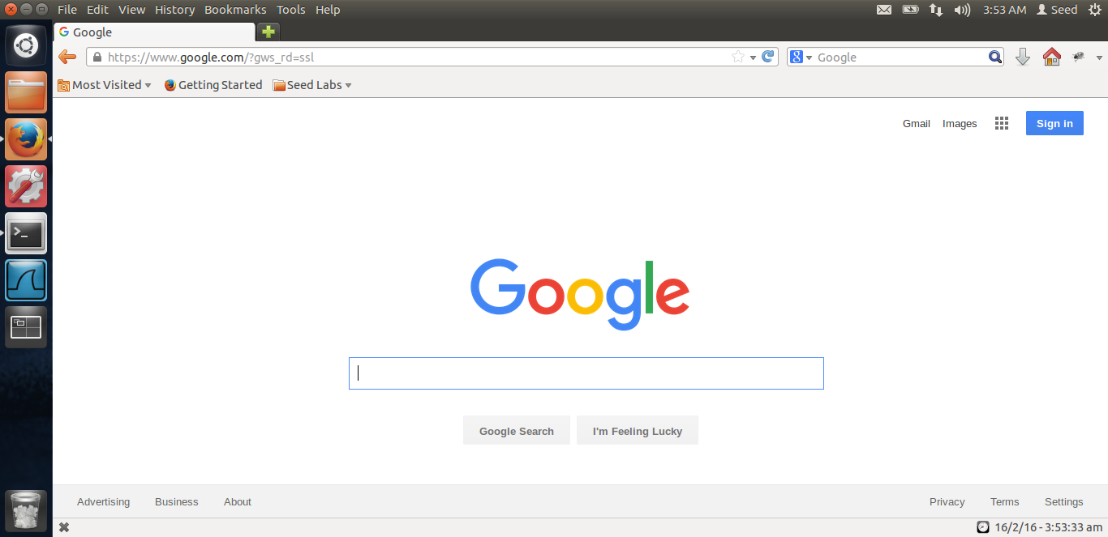

I am able to access google.com

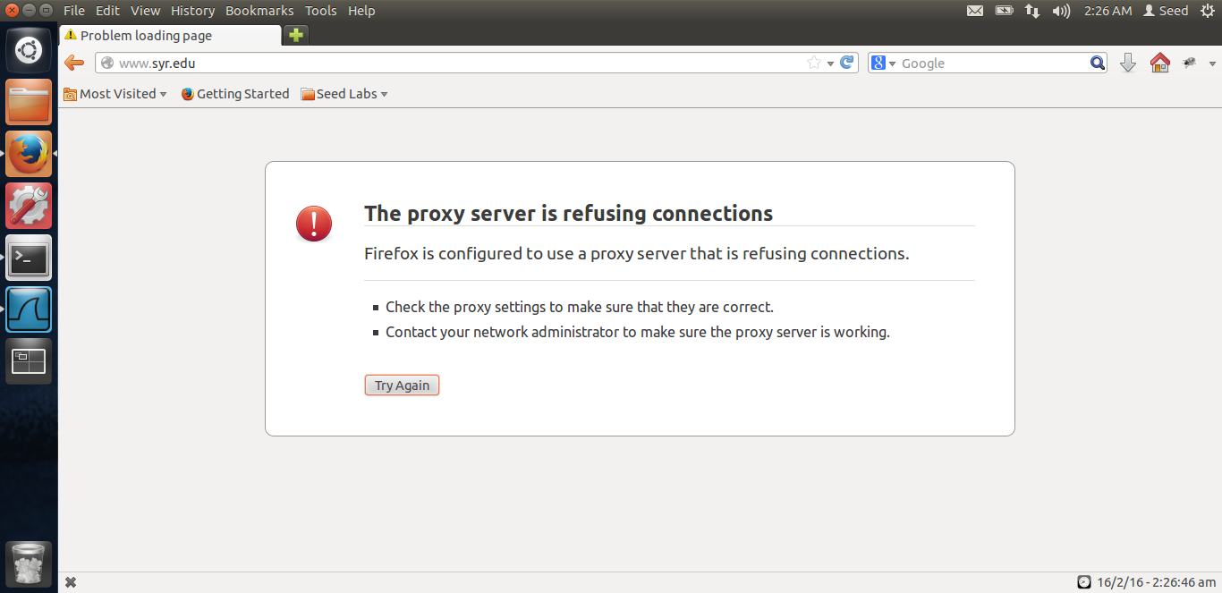

But, if I try to access syr.edu, I am getting blocked. Thus the policy for google.com works.

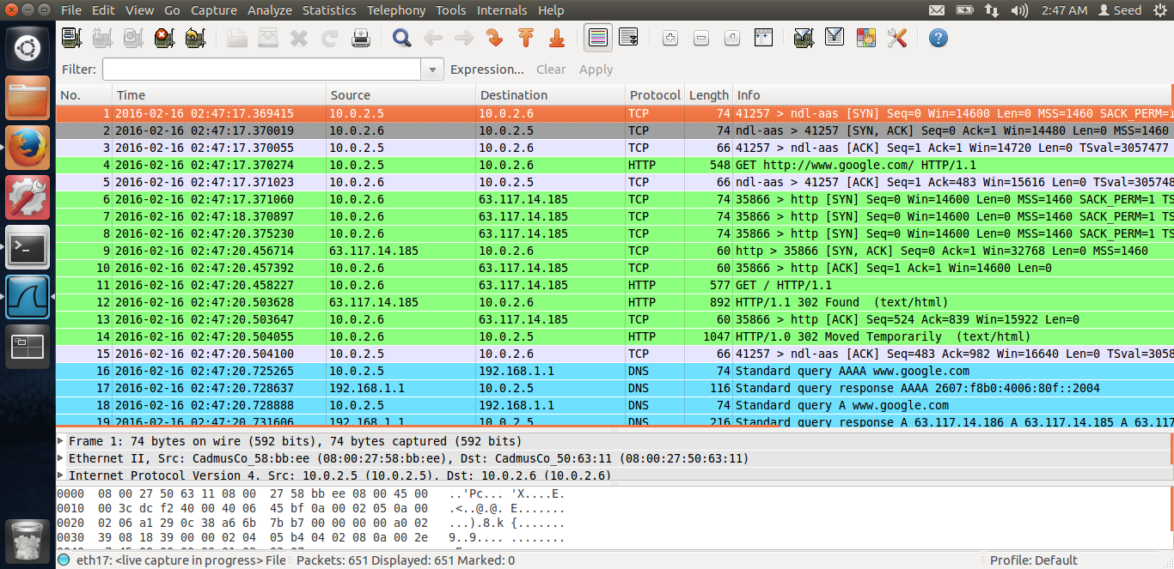

You can see that google.com packets are being sent.

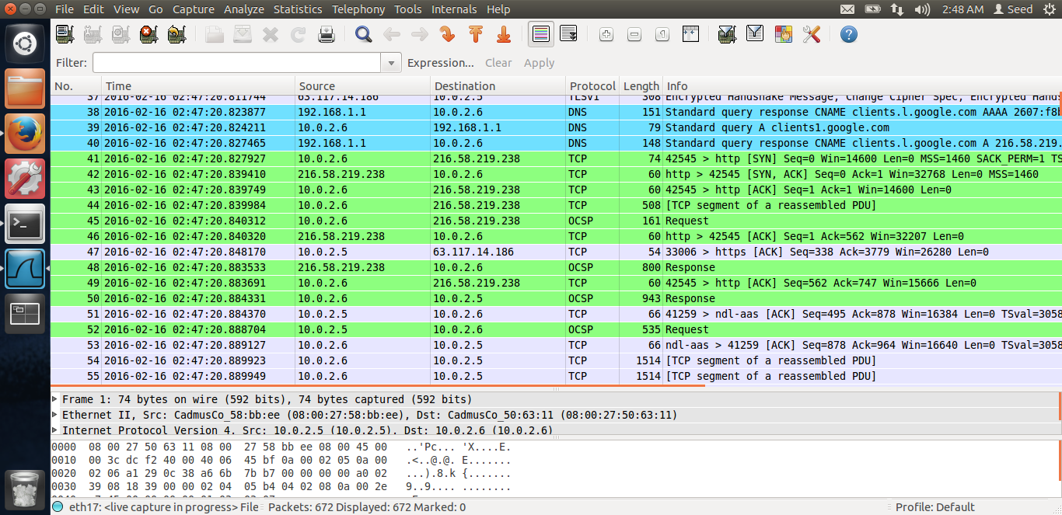

We get the response for google.com.

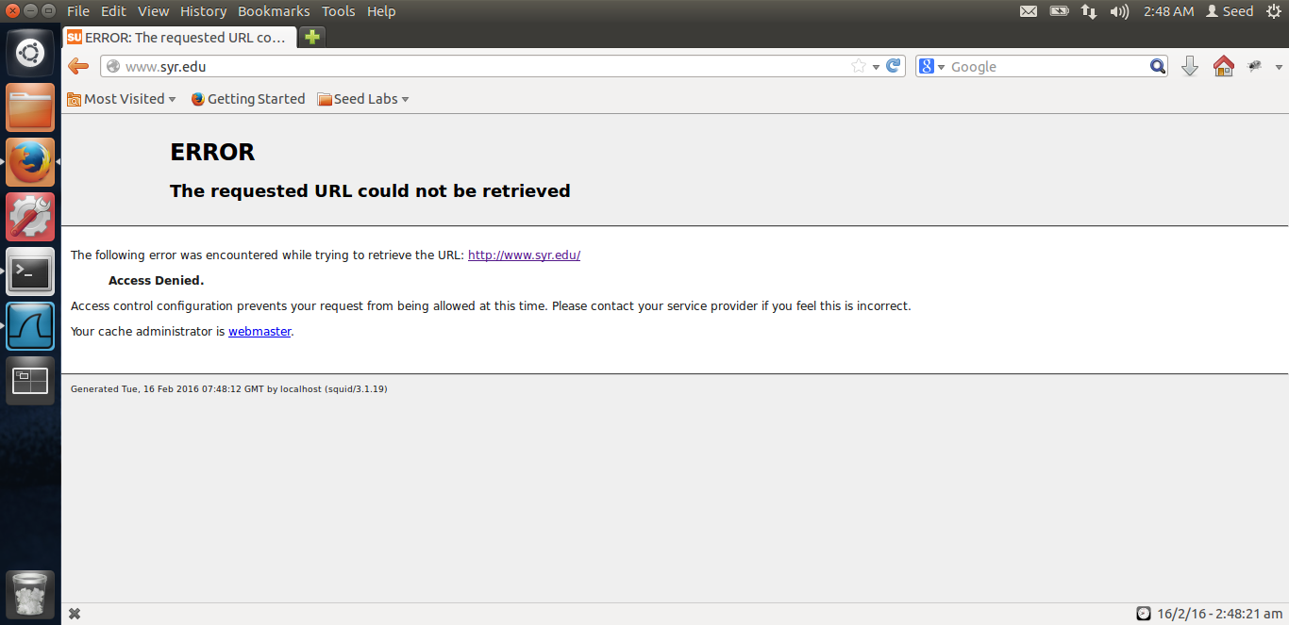

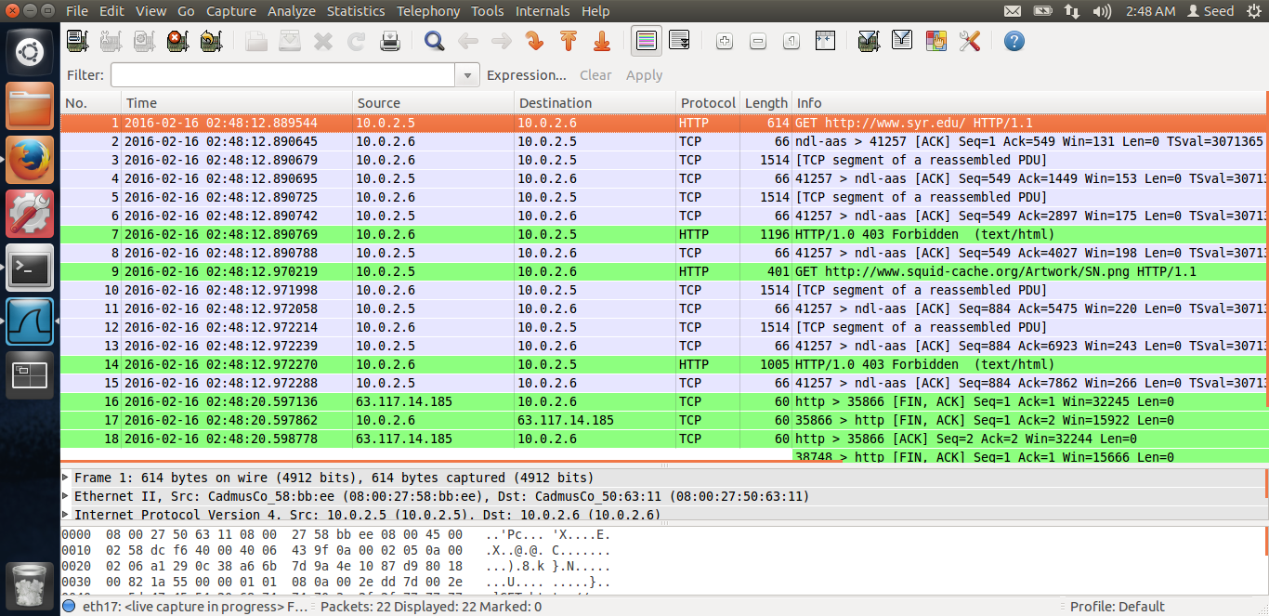

From the screen shot, we can see that [www.syr.edu](http://www.syr.edu), it is forbidden. Thus, the web proxy checks the destination domain, and based on the destination domain, action is being taken.

**Task 4.b Web proxy to evade firewall.**

Web proxies can also be used to evade firewalls. In this task, we will set-up normal firewall i.e. ufw on machine a, my original vm. But we will use squid to evade that.

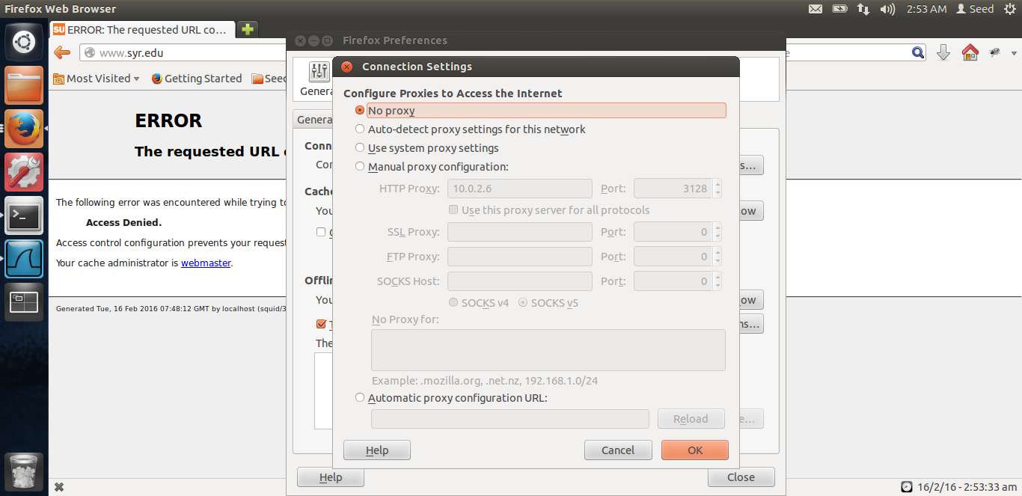

Initially, I am not using any proxy.

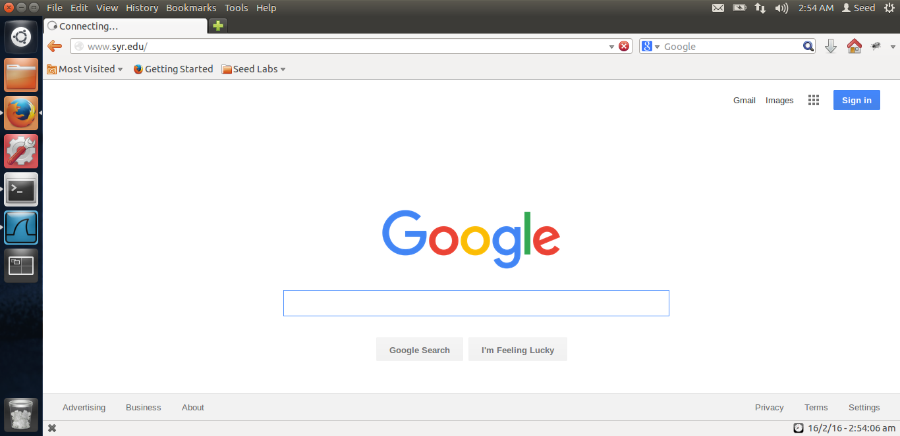

In the above screen shot, we can see that ufw has blocked syr.edu site. In the address bar, the address is syr.edu, but I am not able to open it.

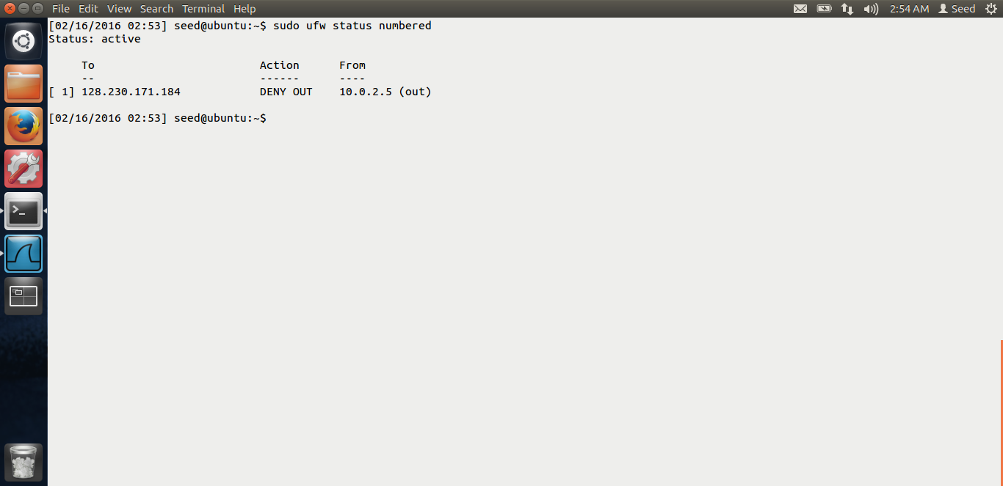

This is the firewall rule, to block syr.edu

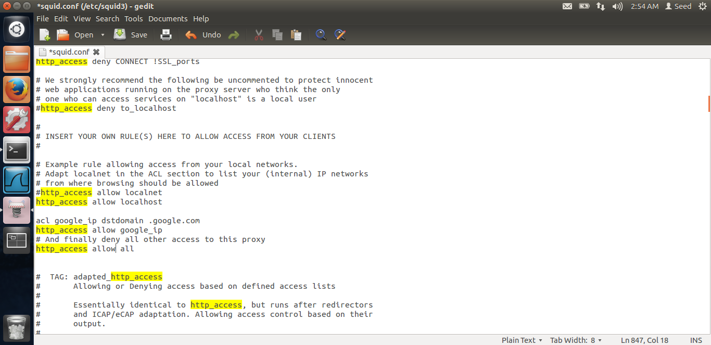

Now, I will use web proxy to access syr.edu. In the squid, I am doing allow all, i.e. allowing all the sites.

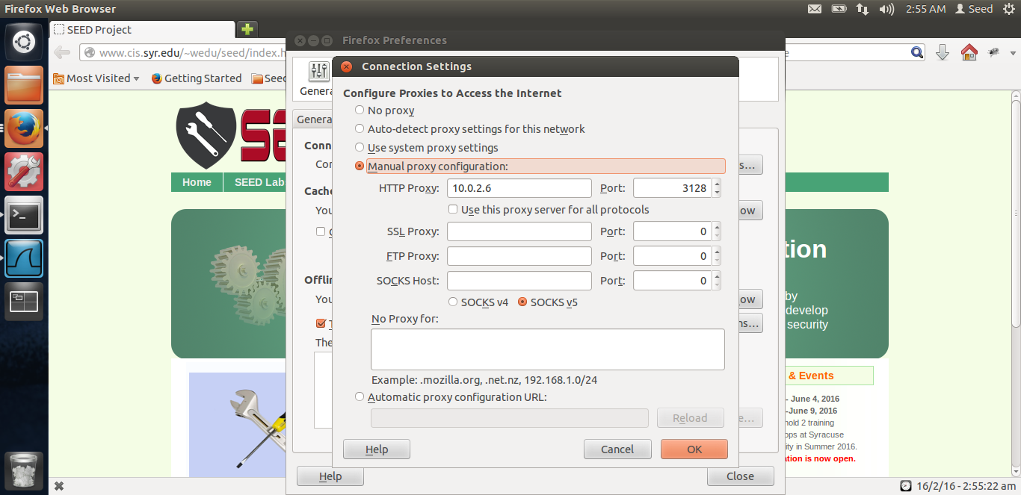

Also, I am changing my proxy settings to use this web proxy to evade firewall. As the proxy has all the sites allowed, I should be able to access syr.edu

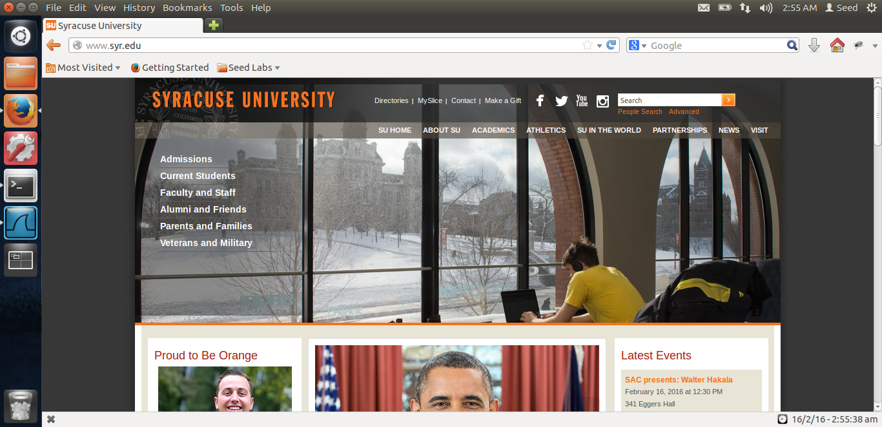

Thus, now if I access syr.edu, I am able to access it. Thus, using web proxy, I am successfully accessing a blocked site.

Question 5:

If ufw blocks TCP port 3128, and if our squid is using 3128, we wont be able to bypass it.

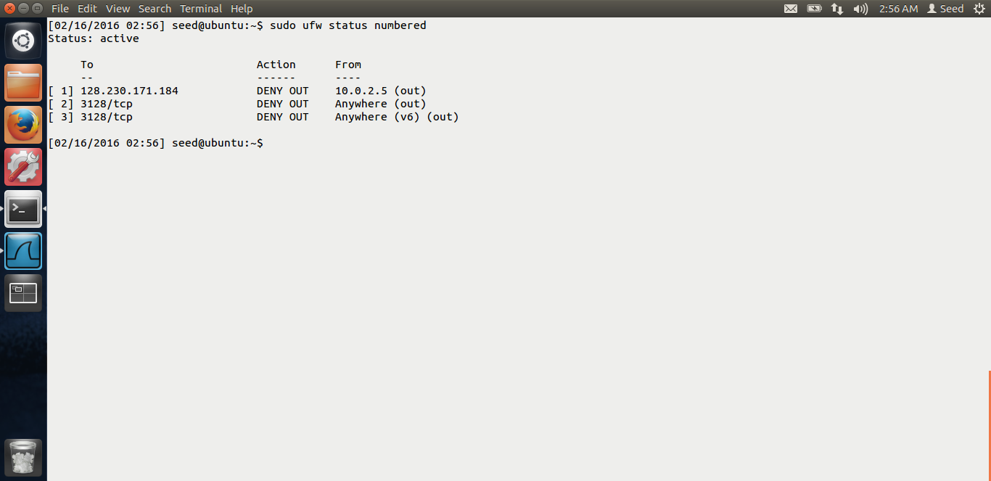

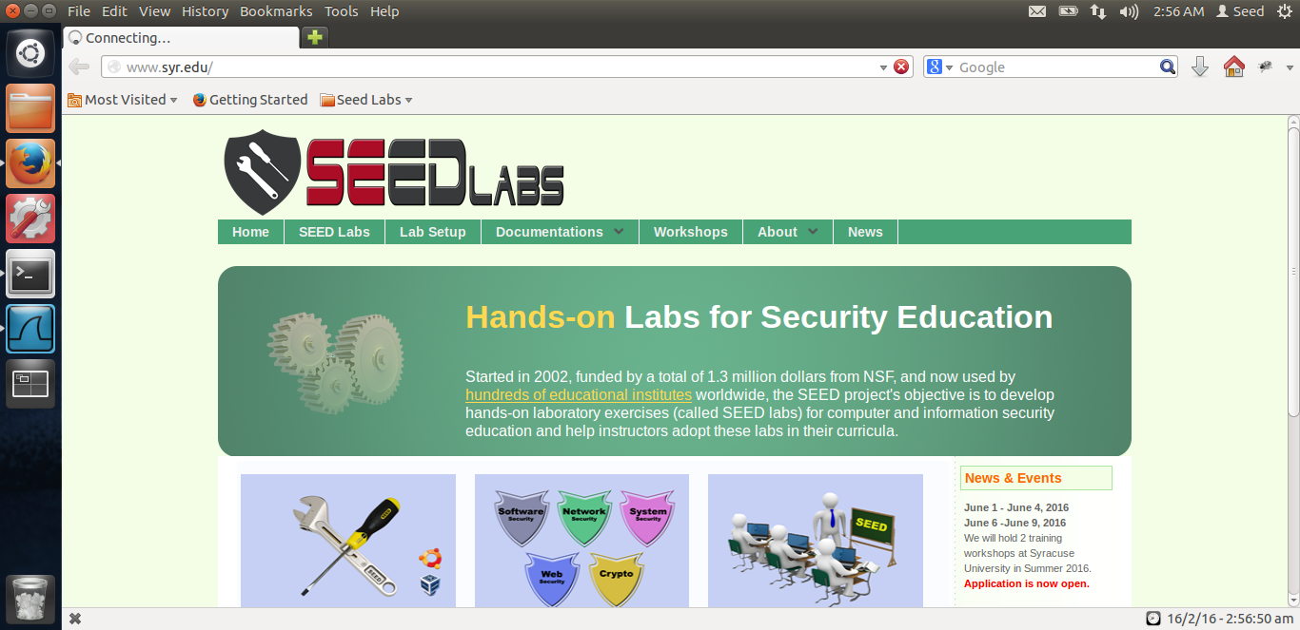

Thus, in the address bar, we can see that syr.edu is blocked again.

But, we can change the port number of squid in the squid config file and we will be able to bypass firewall again.

**Task 4.c URL rewriting**

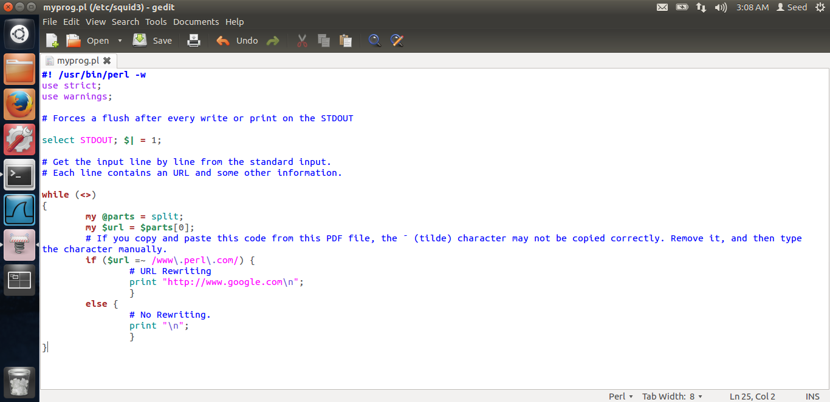

I have modified the program in lab just a little bit. Here, I am re-directing perl.com to google.com

Thus, If in the browser, if someone types [www.perl.com](http://www.perl.com), google’s webpage would be opened.

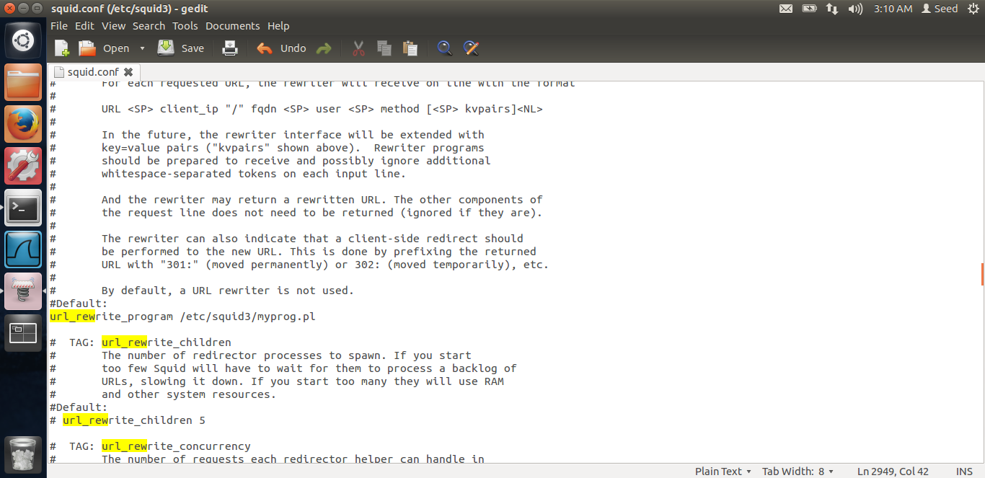

In the config file, we given in the lab, I am adding the url_rewrite_program and including my perl program.

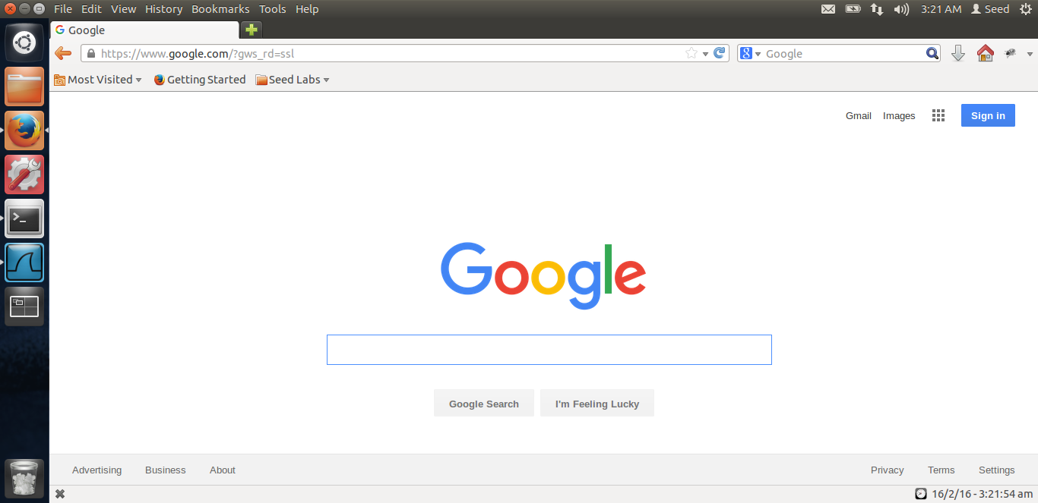

Thus, actually, I had typed [www.perl.com](http://www.perl.com) in the address bar, but I was redirected to [www.google.com](http://www.google.com). Thus, the url redirection works.

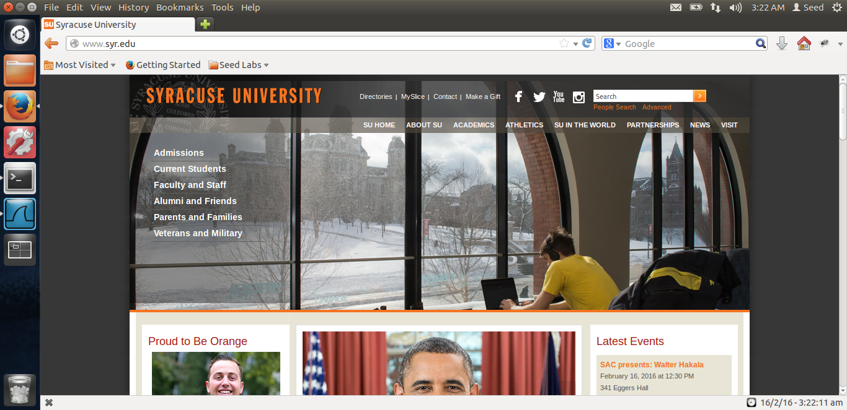

But, I am successfully able to open other sites, I am redirecting only perl.com website.

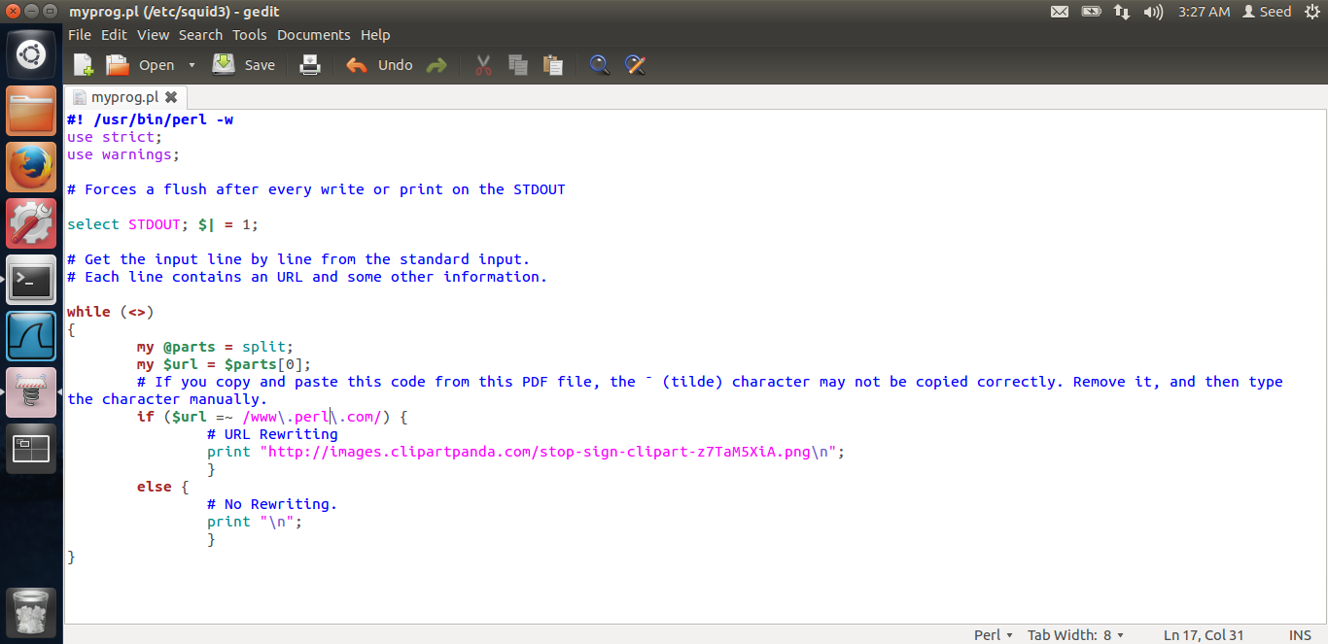

For the second task, I am redirecting perl.com to a stop sign web page. This url I got from google. The url if of the stop sign. So if anyone visits perl.com, he would be redirected to the stop sign.

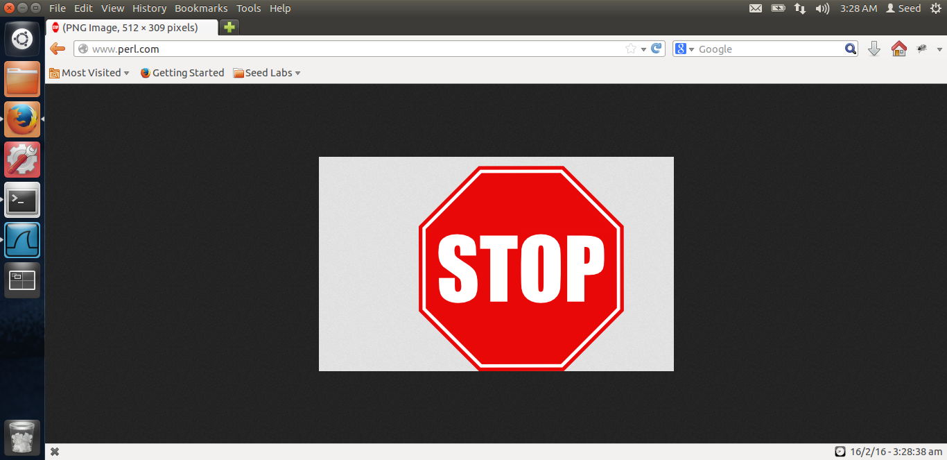

In the address bar, you can see that the website is of perl.com, But this is not perl’s page, instead stop sign has been displayed. Thus the re-direction is successful.

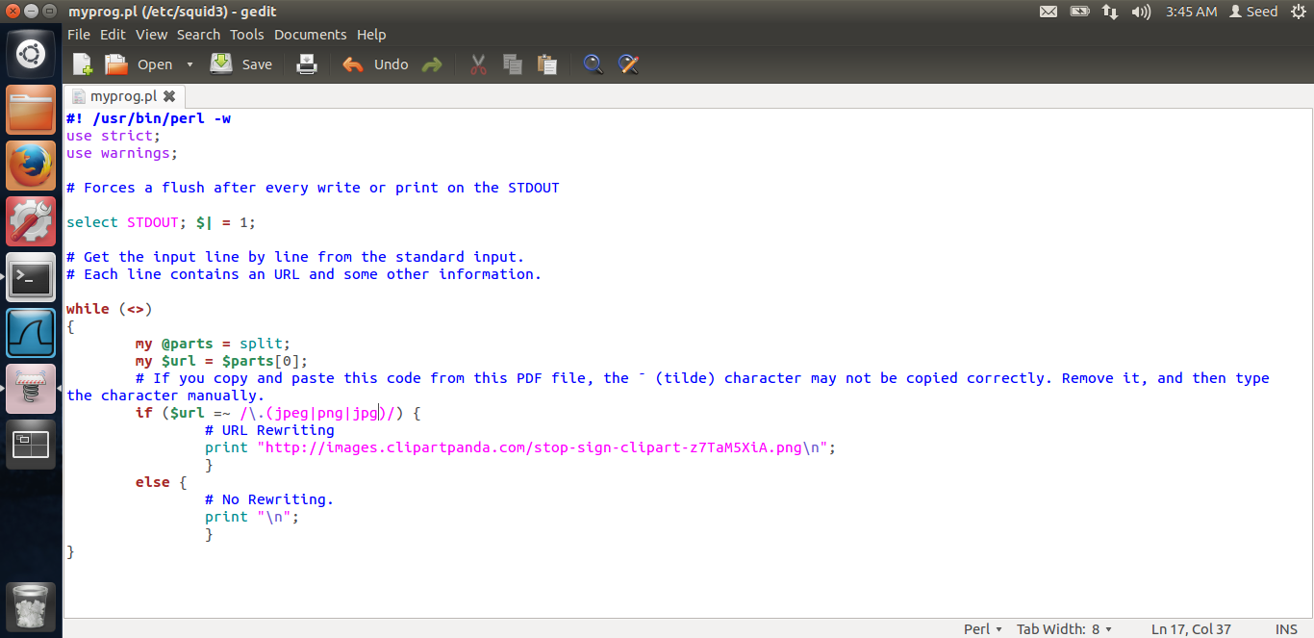

For the last task, I am replacing all the images, i.e. all image types of jpeg,png and jpg with the stop sign. So no website would be redirected, just the images on that website would be replaced by stop sign.

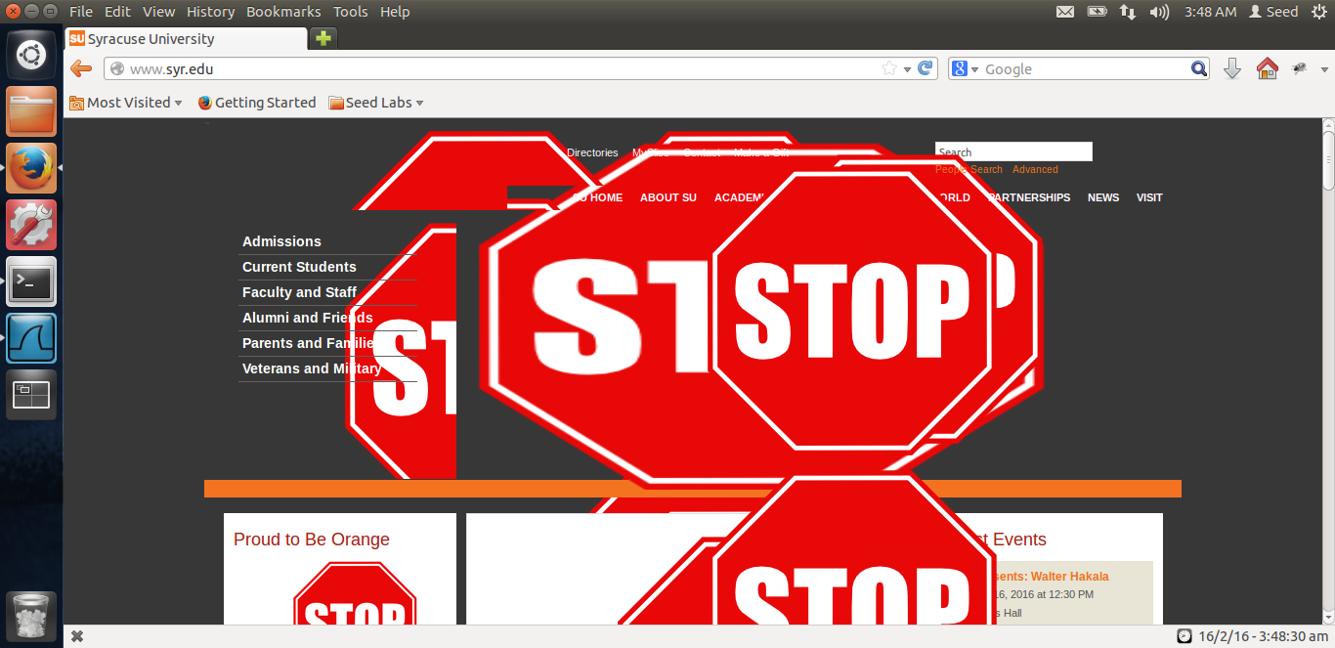

In the above screen shot, we can see that when I visited syr.edu, all its images were replaced by stop sign instead of original images. Thus the attack is successful.

End of task-4 and end of Lab-2.